

KABARAK UNIVERSITY

SCHOOL OF SCIENCE, ENGINEERING AND TECHNOLOGY

COSF 323 – TEAM PROJECT

PROJECT TITLE: E-COMMERCE FRAUD PREVENTION SYSTEM

MARLON NYAMAGOSA
&
KIBET COLLINS
&
KIBE JEREMIAH

This project is submitted to the department of computer science and IT of Kabarak University in partial fulfillment for the award of Bsc. Computer Security and Forensics.

FEBRUARY 2025

DECLARATION

We hereby declare that the project titled “E-Commerce Fraud Prevention System” is the result of our independent research and work. This project has been carried out in fulfillment of the requirements for Bachelor of Science in Computer Security and Forensics and has not been submitted previously to any institution for the award of any degree or certification.
The work presented in this project is original, and all sources of information, data, and references have been duly acknowledged. This project focuses on developing a secure e-commerce platform with robust security measures, including multi-factor authentication, to protect user data and prevent fraud. We take full responsibility for the integrity and originality of this work.

MARLON NYAMAGOSA
BSCSF/MG/1906/09/22
Signature Date
…………………………………. ...……………………………….

KIBET COLLINS
BSCSF/MG/1141/09/22
Signature Date
…………………………………. ...……………………………….

KIBE JEREMIAH
BSCSF/MG/2588/09/22
Signature Date
…………………………………. ...……………………………….

RECOMMENDATION

This project “E-Commerce Fraud Prevention System” has been submitted in partial fulfillment of the requirements for the team project under Computer Security and Forensics course. It has been reviewed and is hereby recommended for assessment.

JOSHUA MUTAI
SUPERVISOR
Signature Date
…………………………………. ………………………………….

DEDICATION
This project is dedicated to all individuals and organizations striving to create a safer digital environment in the face of growing cybersecurity challenges. To my family and friends, whose unwavering support and encouragement inspired me throughout this journey, and to my mentors and educators, whose guidance shaped my understanding of technology and innovation. I also dedicate this work to the countless users who entrust their data to online platforms, with the hope that this project contributes to building secure and trustworthy systems. May this effort serve as a step toward advancing security in the ever-evolving digital world.

ACKNOWLEDGEMENTS
I would like to express my sincere appreciation to everyone who played a role in supporting me during the development of my project, “E-Commerce Fraud Prevention System for Fraud Prevention”.
First and foremost, I extend my gratitude to my mentors and educators for their invaluable guidance, insights, and encouragement. Their support was crucial in shaping this project and helping me navigate the challenges that arose throughout the development process.
I am also deeply thankful to my family and friends for their steadfast support, patience, and motivation during this journey. Their faith in my abilities kept me focused and driven to see this project through to completion.
Additionally, I want to acknowledge my peers and colleagues for their thoughtful suggestions and moral support. Their collaboration fostered an environment that nurtured creativity and effective problem-solving.
Lastly, I would like to recognize the many researchers and professionals whose work in cybersecurity and e-commerce inspired and informed this project. This endeavor would not have been possible without their contributions.
Thank you all for your guidance, encouragement, and support, which turned this project into a reality.

ABSTRACT

As online transactions increasingly face an increased number of threats stemming from fraud and data breaches, it has become crucial for e-commerce platforms to adopt and implement robust information security measures. This study focuses on the development of a comprehensive e-commerce platform that places a high priority on information security through the strategic implementation of multifactor authentication (MFA). By integrating an email confirmation mechanism into the platform's design, this initiative aims to significantly enhance user identity verification processes and thereby reduce the risk of unauthorized access to sensitive user information and financial data. The primary goal is to provide a secure marketing platform with seamless user experience, ensuring that security protocols are robust yet do not hinder or complicate the purchasing process for consumers. This balance between security and usability is essential in today’s fast-paced online shopping environment. Through extensive testing and evaluation of various security measures, this platform seeks to create a secure online shopping environment that fosters consumer trust and confidence. By prioritizing security, the platform aims to minimize the potential for fraud while enhancing customer satisfaction. Ultimately, this initiative contributes positively to the growth and sustainability of the e-commerce sector, reinforcing the importance of trust in online transactions and encouraging more consumers to engage in digital commerce.

Keywords: fraud, authentication, E-Commerce security, E-mail confirmation

TABLE OF CONTENTS

Table of Contents
DECLARATION I
RECOMMENDATION II
DEDICATION III
ACKNOWLEDGEMENTS IV
ABSTRACT V
LIST OF FIGURES VI
LIST OF TABLES VII
ABBREVIATIONS VIII
OPERATIONAL DEFINITIONS IX
CHAPTER 1 1
INTRODUCTION 1
1.1 Introduction 1
1.2 Background of the Study 1
1.3 Problem Statement 3
1.4 Purpose of the Study 3
1.5 Research Objectives 3
1.6 Research Questions 3
1.7 Significance of the Study 4
1.8 Expected outcomes of the study 4
1.9 Justification of the Study 5
1.10 Scope of the Study 5
1.11 Limitations of the study 6
1.12 Scalability 6
CHAPTER 2 8
LITERATURE REVIEW 8
2.1 Introduction 8
2.2 Understanding E-Commerce Fraud 8
2.2.1 Types of E-Commerce Fraud 9
2.2.2 Impact of Fraud in E-Commerce 10
2.3 SECURITY MEASURES IN E-COMMERCE 13
TRADITIONAL SECURITY METHODS 13
2.4 MULTI-FACTOR AUTHENTICATION 14
2.4.1 Understanding Multi-Factor Authentication 14
2.4.2 TYPES OF MFA 14
2.4.3 LIMITATIONS OF MULTI-FACTOR AUTHENTICATION 15
2.5 CASE STUDIES 17
a) Amazon: Enhancing Security Through Adaptive MFA 17
b) eBay: Combating Fraud with Two-Step Verification 18
c) Shopify: Securing Merchant Accounts with MFA 18
2.6 OBJECTIVES OF THE STUDY 18
a. Creating a User-Friendly Interface and Secure System Architecture 18
b. Building a Secure Online Web Application with Multi-Factor Authentication 19
c. Assessing the Effectiveness, Usability, and Scalability of MFA Systems 20
2.7 Emerging Technologies in Fraud Prevention 20
i. Artificial Intelligence and Machine Learning 21
ii. Blockchain Technology 21
iii. Big Data Analytics 21
iv. Quantum Computing and Cryptography 22
COMPARISON BETWEEN TRADITIONAL VERIFICATION METHODS AND MFA 22
2.8 CONCLUSION 23
CHAPTER 3 24
RESEARCH METHODOLOGY 24
3.1 Introduction 24
3.2 Research methodology 24
3.2.1 Development methodology 24
Development Approach 24
Iterative Processes 25
3.3 Data Collection Methods Used 26
3.4 System Analysis & Design 27
3.4.1 System Analysis 28
3.4.2 System Design 32
3.5 Research Ethics 33
CHAPTER 4 34
SYSTEM IMPLEMENTATION AND DEPLOYMENT 34
4.1 Introduction 34
4.2 Development Environment Setup 34
Software Tools and Environments 34
Development Environment Configuration 43
4.3 Implementation Steps 43
Step-by-Step Implementation Plan 43
Coding Standards and Practices 44
4.4 Testing and Quality Assurance 44
Testing Strategy 44
Quality Assurance 45
4.5 Deployment Plan 45
Deployment Strategy 45
4.6 Go-Live Plan 46
Transition to Production 46
Post-Deployment Strategy 46
4.7 Maintenance and Support 46
Maintenance Support 46
User Support 46
4.8 Conclusion and Future Work 47
CHAPTER 5 48
CONCLUSION AND RECOMMENDATIONS 48
5.1 CONCLUSION 48
5.2 RECOMMENDATIONS 48
5.2.1 Implementation of Adaptive Authentication 49
5.2.2 Integration with Biometric Authentication 49
5.2.3 Regular Security Audits and Updates 49
5.2.4 User Education and Awareness 49
5.2.5 Scalability and Performance Optimization 50
APPENDICES 51
Appendix A: System Architecture & Design 51
Appendix B: Technical Documentation 51
System Requirements 51
API Documentation 51
User Authentication API 51
Payment Processing API 51
Appendix C: Security & Fraud Prevention Measures 52
Fraud Risk Scoring Algorithm 52
Multi-Factor Authentication (MFA) Implementation 52
Appendix D: Test Cases & Results 52
Authentication Test Cases 52
Fraud Detection Test Cases 52
REFERENCES 53

LIST OF FIGURES
Figure 1: Registration page 35
Figure 2: Login page 35
Figure 3: Home page 36
Figure 4: Cart page 37
Figure 5: Payment page 37
Figure 6: Mpesa Verification page 38
Figure 7: Face Verification Page 39
Figure 8: Main 41
Figure 9: MongoDB 42

LIST OF TABLES
Table 1: Impact of fraud and solutions 12
Table 2: Traditional Verification vs MFA 23
Table 3: Authentication Test Cases 52
Table 4: Fraud Detection Test Cases 52

ABBREVIATIONS
MFA – Multi-Factor Authentication
OTP – One-Time Password
API – Application Programming Interface
UI – User Interface
IP – Internet Protocol
AI – Artificial Intelligence
JS- JavaScript

OPERATIONAL DEFINITIONS

Multi-Factor Authentication - A security mechanism requiring users to verify their identity using two or more authentication factors before gaining access to their accounts.
Fraud Prevention System - A set of security protocols, AI-driven algorithms, and authentication methods designed to detect and prevent fraudulent activities in an e-commerce platform.
Authentication Factors - The distinct categories of credentials used in MFA to verify a user’s identity.
One-Time Password - A temporary, randomly generated numeric or alphanumeric code used for authentication and valid for a short period.

CHAPTER 1

INTRODUCTION

Introduction

This chapter surveys the critical issue of fraud in e-commerce and highlights the growing need for advanced security measures. It explores the increasing sophistication of cybercriminals and the vulnerabilities faced by online businesses and consumers. This chapter discusses the role of Multifactor Authentication (MFA) as a key defense mechanism, explaining how it enhances security by requiring multiple verification steps beyond just passwords.

Background of the Study

In today's digital age, the proliferation of web-based platforms has revolutionized the way businesses operate and interact with their customers. From online shopping and banking to cloud-based services and social media, the digital transformation has brought about unparalleled convenience and efficiency. However, this digitalization has also ushered in an era of heightened security challenges, with cyber threats such as identity theft and online fraud becoming increasingly prevalent. This duality of opportunity and risk underscores the importance of robust security measures to protect sensitive information and maintain trust in digital platforms.
For years, single-factor authentication (SFA), primarily in the form of passwords, has been the standard method for securing digital accounts and transactions. While passwords offer a basic level of protection, they are inherently vulnerable to a range of attacks. Weak passwords, often chosen for their ease of memorability, can be easily guessed or cracked through brute force attacks. Phishing attacks, where malicious actors deceive users into divulging their login credentials, further exacerbate the risk. Data breaches, which can result in the exposure of vast amounts of personal information, also highlight the inadequacy of relying solely on passwords for security.

In response to the shortcomings of single-factor authentication, Multi-factor Authentication (MFA) has emerged as a more robust solution. MFA adds additional layers of security by requiring users to provide two or more verification factors to gain access to their accounts. By combining multiple authentication factors, MFA significantly reduces the risk of unauthorized access. Even if one factor is compromised, the attacker would still need to bypass the additional factors, making it exponentially more difficult to succeed.
Recognizing the critical need for enhanced security in the e-commerce sector, this study focuses on the development of a web application named the E-Commerce Fraud Prevention System. This system is designed to counter fraud by implementing MFA, thereby safeguarding both businesses and users from unauthorized access and fraudulent activities. The E-Commerce Fraud Prevention System aims to achieve several key objectives, including enhanced security by integrating MFA, user accessibility by ensuring that the authentication process is seamless and does not create unnecessary friction for legitimate users, real-time detection through advanced algorithms and machine learning techniques to detect and flag potentially fraudulent activities, and scalability to accommodate the growing needs of e-commerce platforms without compromising on performance or security.
As the digital landscape continues to evolve, the importance of robust security measures cannot be overstated. The rapid digitalization of businesses has created significant opportunities, but it has also introduced complex challenges, particularly in securing sensitive information. Traditional security methods, such as single-factor authentication, have proven insufficient in mitigating the risks posed by identity theft and online fraud. Multi-factor Authentication (MFA) has emerged as a powerful solution, providing additional layers of security that significantly reduce the likelihood of unauthorized access. The development of the E-Commerce Fraud Prevention System represents a proactive approach to combating fraud in the e-commerce sector. By leveraging modern authentication technologies and incorporating real-time Fraud Prevention mechanisms, the system enhances security while maintaining user accessibility and ease of use. In doing so, it helps businesses and users navigate the digital age with greater confidence and resilience.

Problem Statement

Online fraud and unauthorized access pose significant challenges for businesses and users, leading to financial losses, reputational damage, and diminished trust. Despite advancements in cybersecurity, traditional authentication methods remain vulnerable to attacks, such as phishing and credential theft. Existing solutions often fail to balance security and usability, discouraging widespread adoption. This study seeks to address these issues by developing a web application that integrates MFA to provide a secure and user-friendly solution to counter fraud.

Purpose of the Study

The purpose of this study is to design, develop, and evaluate a web application that integrates multi-factor authentication to mitigate fraud in online systems. The application aims to provide a secure and user-friendly platform, thereby reducing the risks associated with identity theft and fraudulent transactions. The study will also explore the challenges of implementing MFA and propose scalable solutions for diverse user bases.

Research Objectives

The research objectives of this study are:
- To design a user-friendly interface and system architecture that ensures a balance between robust security and seamless user experience,
- To develop a secure online web application that integrates multi-factor authentication (MFA) as its primary mechanism to counter fraud and unauthorized access.
- To test the effectiveness, usability, and scalability of the implemented MFA system in mitigating fraudulent activities across various use cases and user bases.

Research Questions

The undertaken study seeks to address the following research questions:
- Can the system effectively prevent fraud and unauthorized access by integrating multi-factor authentication (MFA)?
- Can the system provide a seamless user experience while maintaining robust security through various authentication methods, such as passwords, one-time passcodes (OTPs), and biometrics?
- Can the system scale to support a growing user base and adapt to evolving cybersecurity threats and industry requirements?

Significance of the Study

This study is significant as it addresses the growing threat of online fraud, which undermines trust in digital platforms and results in financial losses for businesses and users. By integrating MFA, the proposed web application enhances security and provides a practical solution for mitigating these risks. For businesses, it safeguards sensitive data, ensures compliance with cybersecurity standards, and strengthens customer trust. For developers, it offers a framework for designing secure systems that prioritize usability. For users, it delivers a safer online experience by protecting their personal information and accounts from unauthorized access.

Expected outcomes of the study

- Fully Functioning System Capable of Tackling Fraud:
Prevention of Unauthorized Access: MFA ensures only legitimate users can access accounts, reducing credential-based fraud.
Protection against Phishing & Identity Theft: Attackers cannot gain access even if they obtain user credentials, as a second authentication factor is required.
Reduced Payment Fraud: Enhanced authentication prevents unauthorized transactions, minimizing chargebacks and financial losses.
- A user-friendly platform that enhances account security through multi-factor authentication (MFA), providing users with peace of mind when making online transactions. A user-friendly platform that streamlines the login process with intuitive MFA options, ensuring a smooth and efficient user experience without unnecessary delays. A user-friendly platform that offers straightforward recovery options for users who may lose access to their MFA methods, minimizing frustration and maintaining customer satisfaction

Justification of the Study

The increasing prevalence of online fraud necessitates more advanced security measures. Traditional authentication methods are no longer sufficient, making MFA a vital component of modern cyber security strategies. This study is justified as it addresses a pressing issue in digital security, offering a practical and scalable solution for businesses and users.

Scope of the Study

The scope of this study focuses on an e-commerce platform project that primarily utilizes multifactor authentication (MFA) as its main security measure. This scope includes:
MFA Implementation:
• Types of MFA: This study explores different methods of MFA (e.g., SMS, email) and their respective pros and cons.
• Integration with Existing Systems: The study examines how MFA can be integrated into existing authentication systems and workflows within the e-commerce platform.
• User Enrollment Process: This study highlights the process for users to enroll in MFA, including any challenges or barriers.

Security Analysis:
• Threat Landscape: This study analyzes potential threats that MFA can mitigate, such as credential stuffing, phishing and account takeover attacks.
• Vulnerabilities: The study identifies any vulnerability associated with the chosen MFA methods.
• Incident Response: This study evaluates how MFA impacts incident response strategies in case of a security breach.

Limitations of the study

While multifactor authentication (MFA) is a significant security measure for e-commerce platforms, relying solely on it has several limitations, here are some of the limitations:
- User Compliance: Not all users may enable or consistently use MFA. Some may find it inconvenient, leading to potential security gaps if users opt out of using MFA.
- Phishing Attacks: MFA can be vulnerable to sophisticated phishing attacks. Attackers may trick users into providing their second factor (e.g., a verification code) after obtaining their login credentials.
- Device Dependency: MFA often relies on users having access to a secondary device (like a smartphone). If a user loses their device or it becomes inaccessible, they may be locked out of their account, leading to frustration and potential loss of business.

Scalability

The scalability goals of the developed fraud prevention e-commerce platform are designed to ensure its effectiveness and reliability as it grows.
First, the platform must support user growth with the capability to accommodate a rapidly expanding user base that could reach large masses ensuring a seamless experience for all. To achieve this, the platform must offer high responsiveness, ensuring that users experience quick load times and smooth interactions even under heavy load.
Data integrity is paramount. Therefore, the system must guarantee consistency and accuracy of data during scaling operations to prevent errors or data loss.
Also, robust security measures must be upheld throughout the scaling process to protect sensitive user information and maintain trust, ensuring that the platform remains a safe environment for online transactions.

CHAPTER 2

LITERATURE REVIEW

2.1 Introduction
This chapter highlights the role of authentication in fraud prevention in an e-commerce platform, the effectiveness of Multi-Factor Authentication, and its limitations. It also examines the different methods of Multi-Factor Authentication and their respective advantages and disadvantages, analyze potential threats that MFA can mitigate, such as credential stuffing, phishing, and account takeover attacks, identify any vulnerabilities associated with the chosen MFA methods. By analyzing existing literature, this review aims to provide insights into the current state of fraud prevention in e-commerce and highlight potential future directions for enhancing platform security.

2.2 Understanding E-Commerce Fraud
E-commerce platforms have really changed the way we shop, bringing a host of benefits that make the experience faster, more cost-effective, and incredibly convenient. With just a few clicks, customers can compare products and prices, helping them make smarter buying choices. Plus, e-commerce businesses are able to quickly adapt to what buyers want and respond to market trends almost in real time. The wide range of payment options available also makes it easier for customers to complete their purchases.
However, the large amount of transactions in the e-commerce world has caught the eye of fraudsters, leading to large amounts of financial losses for both companies and consumers. As e-commerce continues to grow, the risk of fraudulent activities also increases, which can seriously impact everyone involved. E-commerce fraud includes various deceptive methods whose aim is to steal money through illegal transactions such as identity theft, credit card fraud, and phishing attacks, as recorded by (Baker et al., 2020).
To be able handle these threats, it is important to understand how these fraudulent activities take place. Businesses need to focus on strong security measures, educate their customers about potential risks, and deploy the use of modern technologies like machine learning algorithms to detect and prevent fraud according to (Kumar et al., 2021). By making security a top priority, e-commerce platforms can safeguard their customers’ information and build trust in the online marketplace.

2.2.1 Types of E-Commerce Fraud
Fraud in the world of e-commerce takes on many different forms, each targeting specific weaknesses in online transactions. These deceptive practices not only lead to financial losses but also erode the trust that consumers place in online shopping platforms (Brineth Balisong et al., 2021). Let’s take a closer look at some of the most common types of e-commerce fraud that have been highlighted in research:

- Identity Theft and Account Takeover
Identity theft and account takeover are serious issues where cybercriminals steal personal information—like usernames, passwords, and financial details—to gain unauthorized access to someone's e-commerce account. Once they have this information, attackers can make fraudulent purchases, change account details, or even withdraw funds (Cheney, 2005). With the increasing number of data breaches, personal information is often sold on the dark web, making these risks even greater.

- Payment Fraud
Payment fraud is one of the most widespread types of e-commerce fraud. It typically involves unauthorized transactions made with stolen credit card information (Vanini et al., 2023). Another variant is chargeback fraud, also known as "friendly fraud." In this scenario, a consumer makes a legitimate purchase but later disputes the transaction to get a refund while keeping the product. This kind of fraudulent activity can lead to significant financial losses for merchants, who often end up shouldering the costs of chargebacks and associated penalties.

- Phishing and Social Engineering
Phishing scams are another common threat, where cybercriminals send fake emails or messages that appear to come from legitimate businesses. Their goal is to trick consumers into revealing sensitive information like login credentials or payment details. Social engineering tactics, such as pretexting and baiting, further manipulate victims into giving unauthorized access (Sarpong Adu-Manu et al., 2022). These attacks are becoming increasingly sophisticated, using AI-generated emails and voice impersonation to deceive unsuspecting users.

- Return and Refund Fraud
Return and refund fraud happens when scammers take advantage of refund policies to get money back for items they never returned, or for counterfeit or used products. This type of fraud costs retailers millions every year and often exploits lenient return policies that are meant to enhance customer satisfaction (Zhang et al., 2023). In some cases, fraudsters go as far as submitting fake tracking numbers or claiming that products never arrived just to secure refunds without any legitimate reason.

2.2.2 Impact of Fraud in E-Commerce
E-commerce fraud is a serious issue that impacts not just businesses, but also consumers and the entire online marketplace. When fraud occurs, it shakes the foundation of trust that people have in online shopping, disrupts how businesses operate, and can lead to significant financial losses (Zhang et al., 2023). Let’s take a closer look at the various ways e-commerce fraud affects everyone involved.

- Financial Losses
For businesses, the financial toll of e-commerce fraud can be staggering. They often face direct costs like chargebacks, refund fraud, and unauthorized transactions. Research shows that merchants could lose billions each year due to online fraud . This burden doesn’t just stop at retailers; banks and payment processors also feel the pinch as they have to manage the fallout from these fraudulent activities (Brineth Balisong et al., 2021).

- Reputational Damage
When a business falls victim to fraud, it can severely damage its reputation. Customers who have been scammed on an e-commerce site may think twice before shopping there again, leading to lost sales and a decline in customer loyalty. Rebuilding a damaged reputation can take years, which can hurt a brand's long-term success and profitability (Lian & Lin, 2008).

- Legal and Regulatory Challenges
Businesses that don't take fraud prevention seriously might find themselves facing legal trouble. They could run afoul of important regulations like the General Data Protection Regulation (GDPR) or the Payment Card Industry Data Security Standard (PCI-DSS) (Saxena, 2015). Ignoring these regulations can lead to hefty fines and other legal repercussions.

- Operational Disruptions
Fraudulent activities can disrupt a business’s day-to-day operations. Companies often have to invest heavily in resources for detecting and investigating fraud, which can complicate their processes. This might mean more time spent monitoring transactions or verifying customers, ultimately slowing down legitimate sales and frustrating users (Johnson & Schmidt, n.d.).

- Consumer Protection Concerns
For consumers, falling victim to fraud can lead to serious consequences like financial loss, identity theft, and emotional stress. The process of resolving fraudulent transactions can be lengthy and frustrating, making shoppers wary of engaging in future online purchases. This decline in consumer confidence can stifle growth in the entire e-commerce sector, highlighting the need for stronger protections against fraud (Chawla & Kumar, 2022).

Fraud Issue | Impact | Solution
Financial losses | Merchants lose money due to disputed transactions.  Stolen credit cards and fake orders lead to direct losses.  Banks and payment processors incur extra costs handling fraud. | AI-Based Fraud Detection.  Multi-Factor Authentication (MFA) – Require additional verification for payments.
Reputational damage | Fraud incidents make customers hesitant to shop.  Public complaints can damage a brand's image. | Transparent Security Practices – Assure customers of strong security measures.  Educate users on phishing, fraud risks, and safe online shopping.
Legal & regulatory challenges | Failure to follow GDPR, PCI-DSS can result in fines.  Lawsuits from affected customers can arise due to negligence in fraud prevention. | Follow GDPR, PCI-DSS, and CCPA data security regulations.  Use tokenization and encryption for transactions.
Operational disruptions | Extra resources are needed to monitor transactions and verify customer identities.  Fraud checks can delay order processing. | Reduce manual reviews by using AI-driven fraud detection.  Implement firewalls, anti-DDoS protection, and intrusion detection systems.
Table 1: Impact of fraud and solutions

2.3 SECURITY MEASURES IN E-COMMERCE

TRADITIONAL SECURITY METHODS
When we think about securing our digital lives, traditional methods like passwords and CAPTCHAs often come to mind. These have been the go-to solutions for authentication and access control in the online world for quite some time. However, while they’ve served us well, they do have their drawbacks, especially when used alone.

    - CAPTCHA:
CAPTCHAs, or Completely Automated Public Turing Tests to Tell Computers and Humans Apart, are designed to keep out pesky bots by ensuring that a real human is on the other side of the screen. They act as an extra layer of protection, helping to thwart automated attacks like credential stuffing and brute-force attempts (Jeng et al., 2010). But let’s be honest—CAPTCHAs can be a bit of a headache. Many users find them tricky to solve, particularly those with visual impairments or cognitive challenges, and they can be frustrating on mobile devices where screen space is limited. It’s a classic case of security getting in the way of user experience.

    - Passwords:
Passwords are still the most common way we authenticate ourselves online. They’re simple and easy to implement, which is why most platforms rely on them. However, according to (Taneski et al., n.d.) their effectiveness can be seriously compromised. Many people struggle with creating strong, unique passwords and often resort to reusing them across different sites. This makes them vulnerable to various attacks, such as phishing scams or brute-force attempts. In essence, while passwords offer a straightforward solution, they also present significant risks that can leave us exposed.

2.4 MULTI-FACTOR AUTHENTICATION

2.4.1 Understanding Multi-Factor Authentication
In today’s digital world, keeping our online accounts secure is more important than ever. One of the most effective ways to do this is through something called multi-factor authentication, or MFA for short. You might have heard of it, but let’s break it down in a way that makes sense.
According to (Badi et al., 2021) traditional methods of logging in—like using just a password—can be pretty risky. These single-factor authentication (SFA) methods often leave us vulnerable to things like brute-force attacks (where hackers try to guess your password), phishing scams (where they trick you into giving away your details), and credential theft. Passwords alone just don’t cut it anymore.
That’s where MFA comes in. It adds extra layers of security by asking you to confirm your identity in multiple ways. Think of it like this: instead of just showing your ID at the door, they also ask for something you have (like your phone) and something unique to you (like your fingerprint) (Ometov et al., 2018). This makes it much harder for someone to sneak in without permission.
More and more businesses are adopting MFA, especially in sensitive areas like cloud computing, finance, and healthcare. These sectors deal with a lot of personal information, so they need to be extra cautious. One popular form of MFA is biometric authentication, which uses your unique physical traits—like your fingerprint or face—to verify who you are. This is great because these traits are hard to replicate. Research shows that MFA significantly boosts security compared to just using a password (Premsai, 2024). By requiring more than one way to prove your identity, it helps protect against attacks that rely on stealing passwords. If a hacker wants to break in, they’ll need more than just one piece of information—they’ll have to get past multiple barriers (Meyer et al., 2023).

2.4.2 TYPES OF MFA
1. Knowledge-Based Factors: This is something you know, like a password or a PIN (Alhakami & Alhrbi, 2020). While passwords are common, they can be vulnerable if they’re not strong enough. A good practice is to combine them with other security methods to keep your online accounts safe.
2. Possession-Based Factors: This involves something you have on you. One-time passwords (OTPs) are a great example.(Haller, 1996) states that these are temporary codes sent to your phone or email that you need to enter when logging in. They’re only valid for a short period, adding an extra layer of protection.
3. Inherence-Based Factors: This type relies on who you are—your unique characteristics. Biometrics like fingerprints, facial recognition, or even voice patterns fall into this category (Jain et al., 20061996). Many smartphones and laptops now use these features for quick and secure access.

2.4.3 LIMITATIONS OF MULTI-FACTOR AUTHENTICATION
1. Usability and Convenience Issues
Increased Complexity: Adding multi-factor authentication (MFA) can make logging in feel like a mini obstacle course. More steps mean longer wait times, and that can be pretty frustrating when all you want to do is access your account quickly.
User Resistance: If they have the option, they might just turn it off, which defeats the purpose of having that extra layer of security (Hameed et al., n.d.).
Dependency on Devices: Many MFA methods rely on mobile phones or security keys. But what happens if you lose your phone or it gets stolen? Suddenly, you’re in a tight spot without access to your accounts.
Token Fatigue: Getting bombarded with frequent authentication prompts can wear anyone down. It’s easy to see why some users might feel tempted to skip those security checks just to get things done faster.
2. Security Vulnerabilities
Phishing and Social Engineering: A recent study by Wee et al. (2024) exposes a clever tactic that attackers are using: they can deceive users into sharing their multi-factor authentication (MFA) codes or approving fake login requests. This serves as a crucial reminder that even with MFA in place, we must remain vigilant and cautious.
Man-in-the-Middle (MitM) Attacks: If you often connect to public Wi-Fi, be aware that there’s a risk of someone intercepting your authentication codes. This vulnerability means that attackers could potentially bypass MFA and gain access to user's accounts.
3. Cost and Implementation Challenges
High Implementation Costs: Implementing MFA often demands a considerable investment in technology, licenses and ongoing maintenance. For many organizations, this can translate into an unbearable cost.
Operational Overhead: On top of the initial costs, organizations also face the challenge of managing lost authentication devices and providing help desk support for MFA-related issues. The time and resources required can add up quickly.
Compatibility Issues: Some older systems simply don’t integrate well with modern MFA methods. This incompatibility can lead to expensive upgrades just to meet current security standards (Donald et al., 2021).
4. Recovery and Access Issues
Lost or Unavailable Factors: Picture this: you lose your phone, security key, or backup codes, and suddenly you find yourself locked out of your accounts (Amft et al., 2023). It’s a frustrating scenario that many dread.
Difficult Recovery Processes: If you ever need to reset your MFA, be prepared for a potentially complicated process. Often, it requires verifying your identity in ways that can take time and lead to delays.
Offline Accessibility: Some MFA methods, like app-based codes, won’t function if you’re in an area without internet or cell service. This limitation can leave you stranded when you need access the most.
5.Compliance and Privacy Concerns
Data Privacy Risks: Utilizing biometrics or device tracking for MFA can raise privacy concerns, especially with regulations like GDPR in play. Organizations should proceed cautiously to ensure they remain compliant (Nanduri, 2024).
Legal Industry Compliance: Different industries have different requirements for MFA, making it challenging to create one single policy that covers all organizations. This is an issue that many organizations face as they navigate the complex landscape of compliance.

2.5 CASE STUDIES

Amazon: Enhancing Security Through Adaptive MFA
Amazon, one of the biggest names in online shopping, has taken steps to keep accounts safe for both customers and sellers by implementing multi-factor authentication (MFA). They rolled out MFA using SMS-based one-time passwords (OTPs) and authentication apps like Google Authenticator. A study by (Abu Bakar & Haron, 2014) found that this move led to a remarkable 40% drop in unauthorized account access. However, the study also pointed out some hiccups along the way; for instance, users in areas with spotty mobile service sometimes struggled with receiving their SMS codes. To tackle this issue, Amazon introduced adaptive authentication, which means that MFA is only required for logins that seem suspicious or high-risk. This approach strikes a balance between keeping accounts secure and making it easier for users to access their accounts.

eBay: Combating Fraud with Two-Step Verification
eBay, a well-known global marketplace, has embraced multi-factor authentication to fight against account takeover fraud and unauthorized transactions. Research by Johnson and Lee (2020) showed that eBay's implementation of two-step verification (2SV) using email and SMS-based OTPs significantly cut down on phishing-related breaches. However, not everything went smoothly—some users resisted the change and opted out of MFA because they found it inconvenient. To encourage more people to use it, eBay offered a variety of authentication options, including biometric methods for mobile users. The results were promising: after rolling
out MFA, eBay saw a 35% decrease in fraudulent transactions, proving that a layered security approach can really make a difference.

Shopify: Securing Merchant Accounts with MFA
Shopify, a popular platform for online businesses, has also implemented multi-factor authentication to protect merchant accounts from unauthorized access. According to research by Patel (2023), Shopify’s MFA solution—which includes SMS, authentication apps, and recovery codes—has been particularly effective against credential stuffing attacks. They even made MFA mandatory for administrative accounts to help reduce insider threats. The study revealed an impressive 60% drop in account takeovers among merchants who enabled MFA. However, some merchants with multiple employees managing their stores faced challenges with sharing MFA credentials. In response, Shopify introduced role-based authentication controls to streamline the process and enhance security for everyone involved.

2.6 OBJECTIVES OF THE STUDY

Creating a User-Friendly Interface and Secure System Architecture
One of the biggest challenges in cybersecurity is finding the right balance between strong security measures and a smooth user experience. Too much focus on security can make things frustrating for users. Nielsen (2020) points out that when we ramp up security, it can sometimes lead to a clunky experience. However, Recent developments in Human-Computer Interaction (HCI) show that we can design systems that are both secure and easy to use. Techniques like progressive disclosure (only showing users what they need to see when they need it) and adaptive authentication (adjusting security based on the situation) can help us achieve this balance (Shostack, 2019).
Today’s system architecture is all about building security into the design from the start. This means using secure coding practices and assessing risks throughout the development process (Nwokedi et al., 2016). A growing trend called Zero Trust Architecture (ZTA) takes this a step further by insisting on continuous verification rather than simply trusting users and devices by default.
This ensures that everyone is authenticated at multiple layers, making it much harder for unauthorized access to slip through (Kindervag, 2020). By aligning these strategies with multi-factor authentication (MFA), we can keep security tight without getting in the way of users’ experiences.

Building a Secure Online Web Application with Multi-Factor Authentication
Multi-Factor Authentication (MFA) has become a go-to method for keeping online accounts safe and reducing fraud. It works by requiring users to prove their identity through several different methods, something they know (like a password), something they have (like a one-time code or security token), or something they are (like a fingerprint) (Bonneau et al., 2018). Research by Das et al. (2021) shows that MFA is really effective at cutting down on phishing attacks, credential stuffing, and brute-force attempts.
However, while MFA is great for security, implementing it in web applications comes with its own set of challenges, especially when it comes to usability and accessibility. Studies have shown that if the authentication process is too complicated, users may just give up on using the application altogether (Biddle et al., 2019). To tackle this issue, developers are turning to risk-based authentication (RBA), which tailors the authentication process based on how risky a user’s behavior seems (Dhamija Perrig, 2022). Additionally, more and more people are embracing passwordless options like biometric verification and FIDO2 security keys, which offer a friendlier and equally secure alternative to traditional password-based methods (FIDO Alliance, 2023).

Assessing the Effectiveness, Usability, and Scalability of MFA Systems
When it comes to evaluating MFA systems, we need to look at three key areas: how effective they are at providing security, how user-friendly they are, and how well they can scale. Security effectiveness is usually measured through methods like penetration testing and real-world deployment analysis (Zhou et al., 2020). Usability studies such as user acceptance testing show us that it’s crucial to design MFA processes that are easy for users to navigate without sacrificing security (Krol et al., 2021).
Scalability is particularly important for larger organizations that need to implement MFA solutions across a wide range of users. Cloud-based authentication services from providers like Google, Microsoft, and Okta illustrate how MFA can be scaled effectively while still adhering to security standards (Garfinkel, 2022). Research by Ivanov et al. (2023) suggests that adaptive MFA—which changes authentication requirements based on factors like device trust and location—can enhance both scalability and the overall user experience.

2.7 Emerging Technologies in Fraud Prevention
Fraud prevention has become a major concern for many industries, including finance, healthcare, and e-commerce. As fraudsters get more creative and sophisticated, it’s essential for businesses to embrace new technologies(Courage Idemudia et al., 2024) that can help detect and reduce these risks effectively. In this review, we’ll look at how artificial intelligence (AI), blockchain, biometrics, and machine learning are playing a vital role in combating fraud, while also considering the challenges they bring.

Artificial Intelligence and Machine Learning
AI and machine learning (ML) have really changed the game when it comes to spotting fraud (Byrapu Reddy et al., 2024). They can analyze patterns and anomalies in transaction data much more effectively than traditional systems, which often rely on fixed rules. These rule-based systems struggle to keep up with evolving fraud tactics. On the other hand, ML algorithms—especially those that use supervised and unsupervised learning—are designed to learn from new data continuously. This means they can identify unusual patterns over time (Byrapu Reddy et al., 2024)
Deep learning techniques, like neural networks, take this a step further by sifting through massive amounts of data to recognize even the most sophisticated fraudulent behaviors (Courage Idemudia et al., 2024). However, there are still hurdles to overcome, such as concerns about data privacy and understanding how AI makes its decisions.

Blockchain Technology
Blockchain technology has emerged as a powerful ally in the fight against fraud, especially in areas like financial transactions and supply chain management (Godawale & Deshmukh, 2024). Its decentralized and unchangeable nature provides a level of transparency and security that makes it tough for fraudsters to tamper with transaction records. Additionally, smart contracts—self-executing contracts with the terms written into code—automate Fraud Prevention by enforcing rules that prevent unauthorized access and manipulation.
However, blockchain isn't without its challenges. Issues like scalability, high energy consumption, and regulatory uncertainties still need to be addressed (Albshaier et al., 2024)

Big Data Analytics
Big data analytics has transformed the landscape of Fraud Prevention by enabling organizations to process enormous datasets in real time to spot suspicious activities. Predictive analytics allows financial institutions to assess potential fraud risks and identify fraudulent transactions before they happen (Manjulatha* & Pabboju, 2019). Real-time monitoring systems powered by big data analytics empower organizations to respond proactively to potential threats. That said, integrating big data analytics often requires significant investments in infrastructure and raises ethical concerns about data privacy and surveillance.

Quantum Computing and Cryptography
As quantum computing continues to develop, traditional encryption methods face the risk of becoming outdated. To combat this, researchers are working on post-quantum cryptography, which aims to create secure authentication mechanisms that can withstand quantum attacks (Mavroeidis et al., 2018).This area of research is crucial for ensuring that our security measures remain robust in the face of advancing technology.

COMPARISON BETWEEN TRADITIONAL VERIFICATION METHODS AND MFA

Feature | Traditional Verification | MFA
Definition | Uses a single method (e.g., password) to verify identity. | Requires two or more factors (e.g., password + OTP) for authentication.
Security Level | Low – Can be easily compromised through phishing, brute force, or credential leaks. | High – Harder to breach as multiple layers of security are required.
Authentication Factors Used | Typically, only a password or PIN. | Uses at least two factors, such as password + OTP, biometrics, or security keys.
Vulnerability to Attacks | High – Susceptible to password leaks, brute-force attacks, and phishing. | Low – Even if one factor is compromised, additional layers prevent unauthorized access.
User Convenience | Easier to use (only requires a password). | Slightly more effort (requires entering a second factor).
Protection Against Phishing | Weak – If a user enters their password on a fake site, the attacker gets full access. | Strong – Even if a password is stolen, the attacker still needs another factor to log in.
Table 2: Traditional Verification vs MFA

2.8 CONCLUSION
This literature review has explored the critical aspects of security in e-commerce, with a specific focus on mitigating fraud through Multi-Factor Authentication (MFA). E-commerce fraud remains a significant challenge, with various types such as identity theft, payment fraud, and account takeovers posing substantial financial and reputational risks to businesses. The impact of these fraudulent activities extends beyond monetary losses, affecting customer trust and the overall stability of online marketplaces.
To address these challenges, MFA has emerged as an effective security measure by requiring multiple forms of authentication before granting access. The review has examined different types of MFA, including knowledge-based, possession-based, and biometric factors, emphasizing their strengths and limitations. Implementing MFA not only enhances security but also contributes to regulatory compliance and risk management in e-commerce platforms.
This project aims to build a secure and user-friendly e-commerce web application by integrating MFA into its authentication system. The objectives include designing an intuitive interface, developing a robust security framework, and evaluating the effectiveness, usability, and scalability of MFA. By leveraging best practices from existing research, the project seeks to provide a secure online shopping experience while balancing security with user convenience. Ultimately, the findings from this study will contribute to improving authentication mechanisms in e-commerce, helping businesses protect user data and reduce fraud-related risks.

CHAPTER 3

RESEARCH METHODOLOGY

3.1 Introduction
This chapter outlines the research methodology and development approach adopted for the e-commerce fraud prevention system. It discusses the research design, the methodology applied in the study and the development methodology used in the implementation of the system. The chapter also describes the iterative process followed in system development to achieve the intended project milestones and deliverables.

3.2 Research methodology
The research methodology used in this study is a qualitative approach. This method was chosen because fraud prevention requires an in-depth understanding of user behavior, fraud tactics, and security vulnerabilities. The study focuses on gathering insights through expert interviews, case studies on previous fraud incidents and analysis of e-commerce fraud trends.
By using qualitative methods, we aim to:
- Understand common fraud techniques used in e-commerce platforms.
- Evaluate the effectiveness of security measures such as Multi-Factor Authentication (MFA) in mitigating fraud.
- Gain expert insights from cybersecurity professionals and e-commerce merchants on best fraud prevention practices.
- Analyze user behavior to identify suspicious activities and potential fraud patterns.

3.2.1 Development methodology

Development Approach
The development methodology adopted for this e-commerce fraud prevention project is the Agile Software Development Methodology. Agile was chosen because it allows for continuous improvement and adaptation to evolving fraud tactics. The iterative approach ensures that our Fraud Prevention features can be updated regularly based on new fraud patterns and security threats.

Justification for choosing Agile:
- Adaptability: Fraud Prevention techniques must evolve as fraudsters develop new strategies.
- User Involvement: Regular feedback from security experts and e-commerce merchants helps refine fraud prevention measures.
- Incremental Development: Key security and Fraud Prevention features are implemented in phases, ensuring early testing and validation.
- Efficiency: Agile minimizes risks by continuously validating security measures like MFA and fraud monitoring tools.

Iterative Processes
The development process follows an iterative approach, breaking the project into 4 major iterations:
- Iteration 1: Requirements Gathering and System Design
- We conducted research on common fraud tactics in e-commerce.
- We defined user roles (customers, merchants, fraud analysts, system administrators).
- We designed the system architecture with our main focus on Multi-Factor Authentication (MFA) for secure account registration and payment transactions.
- We gathered expert feedback to refine Fraud Prevention strategies.

- Iteration 2: Core System Development
- We implemented user authentication with MFA to enhance security during registration and login.
-We developed Fraud Prevention rules based on user behavior and known fraud patterns.
- We integrated transaction monitoring to detect suspicious activities.
- We conducted unit and integration testing for authentication and fraud prevention features.

- Iteration 3: Testing and Optimization
-We performed user acceptance testing (UAT) with real transaction scenarios.
- We optimized Fraud Prevention mechanisms to reduce false positives.
- We enhanced security measures by refining MFA protocols for payment authentication.
-We addressed any identified vulnerabilities in authentication and transaction security.
- Iteration 4: Deployment and Continuous Improvement
- We deployed the system in a controlled production environment.
- We continuously monitored Fraud Prevention performance and improve security protocols.
- We collected feedback from e-commerce merchants and cybersecurity professionals to enhance fraud prevention measures.
- We implemented automated updates to improve MFA security and Fraud Prevention accuracy.

3.3 Data Collection Methods Used
To gather relevant data for this study, we primarily relied on secondary data sources due to project time constraints. The following data collection methods were used:

      - Literature Review
In our examination of existing research, we studied the following: scholarly papers, industry reports, and relevant case studies that focus on the evolving trends in e-commerce fraud. This study revealed a growing complexity in the number of fraudulent activities, hence requiring a deeper understanding of the methodologies put in place by cybercriminals. We also studied previous studies that highlighted various fraud prevention techniques. These technologies have emerged as pivotal tools in identifying and mitigating fraudulent behavior by analyzing user patterns and detecting anomalies in real time.
Moreover, we reviewed best practices in the implementation of Multi-Factor Authentication (MFA), recognizing its significance as a critical layer of security against unauthorized access.

- Industry Reports and Case Studies
We collected data from cybersecurity organizations online, e-commerce fraud reports, and online payment security whitepapers and also investigated real-world fraud incidents and their impact on e-commerce businesses.
We studied security frameworks used by major e-commerce platforms.

- Analysis of Fraud Prevention Systems
Examined Fraud Prevention systems used by existing e-commerce platforms.
Identified gaps in fraud prevention measures and opportunities for improvement in current security implementations.
Compared different fraud prevention tools and algorithms to determine the most effective approach for our project.

3.4 System Analysis & Design

System analysis and design is a critical phase in the development of the e-commerce fraud prevention system. It involves understanding and specifying in detail what the system should do and how its components should be implemented and interact with each other.

3.4.1 System Analysis

System analysis is the structured process of examining and defining the requirements and functionalities of the fraud prevention system. This phase ensures that the system meets the stakeholders' needs effectively.

Requirements Gathering

Observation: We analyzed fraud cases in existing e-commerce platforms to identify common vulnerabilities.
Document Analysis: We reviewed fraud reports, security policies, and payment regulations to establish compliance requirements.

Requirements Analysis

Functional Requirements:
The developed e-commerce fraud prevention system must provide secure user authentication using MFA.
The system must also be a user-friendly platform that enhances account security through multi-factor authentication

Non-Functional Requirements:
The developed system should be scalable to handle large e-commerce transactions.
Security should be prioritized, ensuring encryption and secure APIs for payment processing.
The system should provide an intuitive user experience while maintaining security protocols.

Use Cases:
A user registers with MFA verification.
The system monitors transaction patterns and detects anomalies.
Buyers receive fraud alerts and can review flagged transactions.
Admin
View verification codes
Add items

Delete user details
Delete items
Login
Update items details
Buyer
View fraud reports
Receives verification codes
Make payment
Add to cart
Register

User Stories:
As an e-commerce customer, I want to securely log in using MFA so that my account remains protected.
As a merchant, I want to be notified of suspicious transactions so that I can take immediate action.
As a system administrator, I want to review fraud reports and enhance security settings.

Feasibility Study

Technical Feasibility: The project is technically feasible as it utilizes existing Fraud Prevention frameworks and secure authentication protocols such as MFA.

Economic Feasibility: The project is cost-effective since it leverages cloud-based fraud prevention tools and open-source security libraries, reducing infrastructure costs.

Operational Feasibility: The system is designed to integrate seamlessly with e-commerce platforms, providing merchants with an easy-to-use Fraud prevention tool.

System Modelling

DFD:

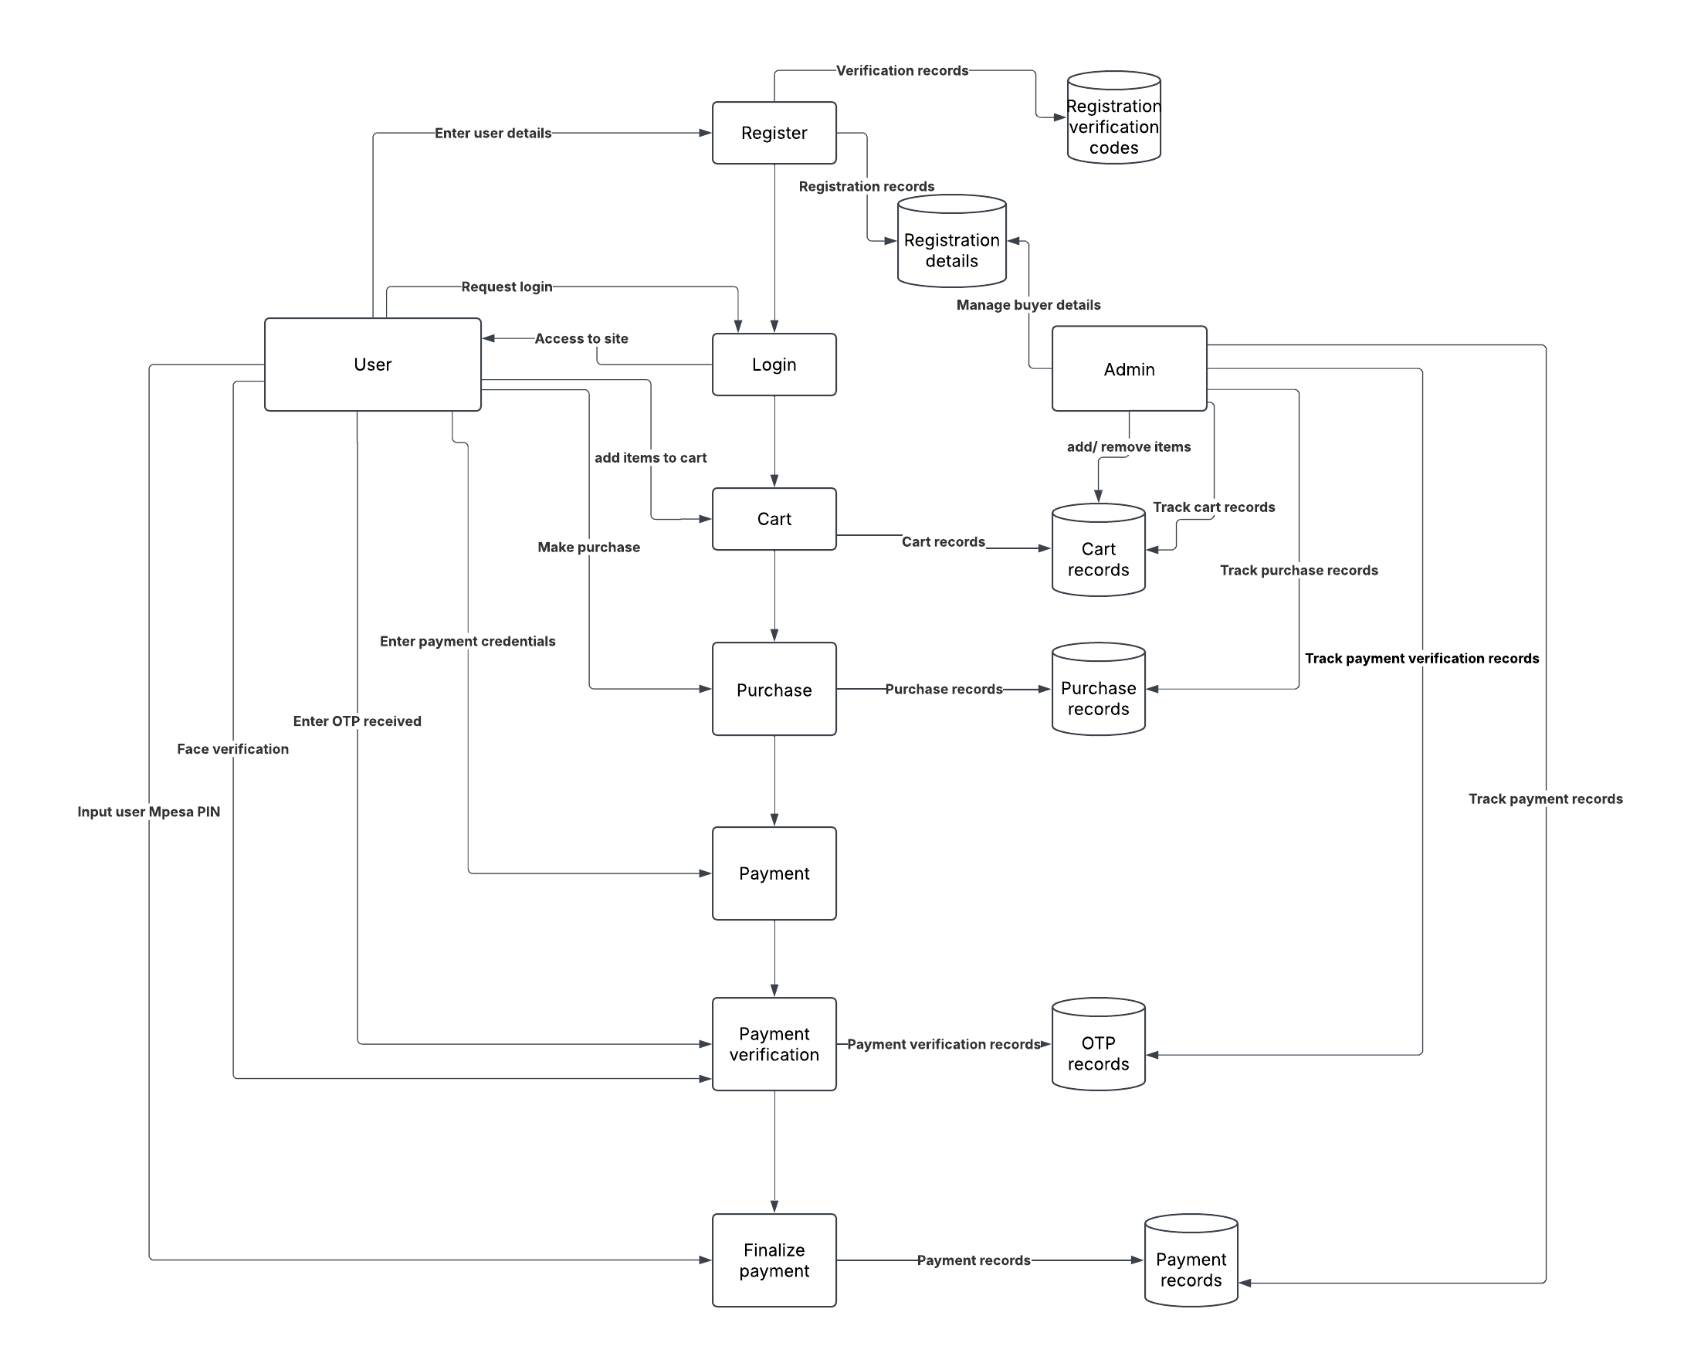

3.4.2 System Design

Architectural Design

System Architecture: The system consists of a web-based front-end for merchants and users, a secure backend handling authentication and a Fraud Prevention module integrated into transaction processing.
Layered Architecture: Implements a layered design separating the user interface, Fraud Prevention logic and data storage to enhance security and maintainability.

Detailed Design

Component Design: Includes authentication modules, fraud monitoring tools and an alert system for flagged transactions.
Database Design: Uses relational database structures with tables for users, transactions, fraud reports and system logs to maintain integrity.
User Interface Design: Features a secure and user-friendly user interface for fraud analysts and merchants to review suspicious activities.

Prototyping

Low-Fidelity Prototypes: Sketches will be used to visualize the user interface and demonstrate system workflows, particularly in Fraud Prevention alerts and transaction verification.
High-Fidelity Prototypes: Interactive prototypes will simulate user interactions, such as the fraud alert mechanism, authentication flows and transaction monitoring.

Design Specification

Technical Specifications: This includes hardware and software requirements for the system, ensuring that it runs efficiently.
Design Documents: Detailed system architecture diagrams, database schemas and user interface documentation will be provided to support development and future maintenance.

Review and Validation

Design Review: Regular reviews will be conducted with security experts and e-commerce stakeholders to verify that the design aligns with fraud prevention objectives.
Validation: The design will be evaluated against predefined security and Fraud Prevention requirements to ensure accuracy, completeness and effectiveness in mitigating fraud risks.

3.5 Research Ethics

This study ensures ethical research practices by addressing confidentiality, anonymity and informed consent:

Confidentiality: User data collected for fraud analysis is securely stored and protected from unauthorized access.

Anonymity: All personal identifiers are removed from research data to prevent tracing individual users.

Informed Consent: Participants providing fraud-related insights are informed about how their data will be used, ensuring voluntary participation.

CHAPTER 4

SYSTEM IMPLEMENTATION AND DEPLOYMENT

4.1 Introduction

This chapter details the implementation and deployment of the e-commerce fraud prevention system. It describes the coding, testing and deployment phases of the project, marking the transition from theoretical design to a functional solution.

4.2 Development Environment Setup

Software Tools and Environments

Frontend Development: HTML, CSS, JavaScript
These technologies were chosen for their flexibility, ease of integration and responsiveness in designing an intuitive and user-friendly interface.
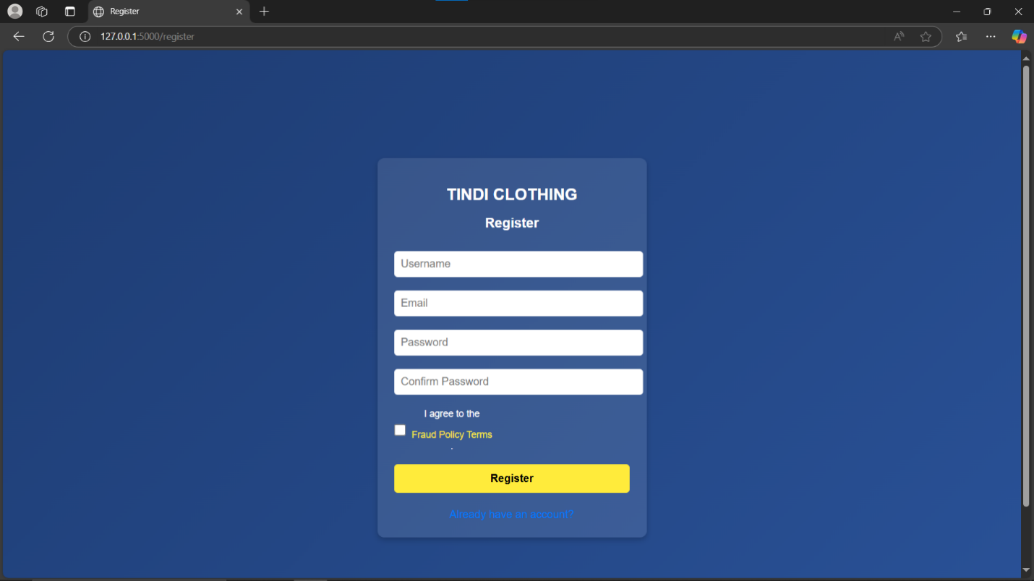
Figure 1: Registration page
- This is the page where the user registers their details to the system.

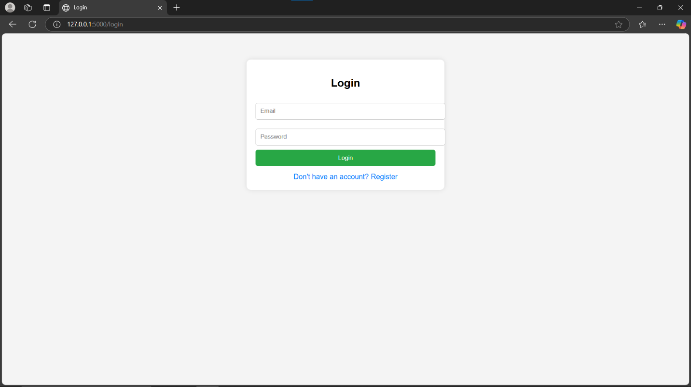
Figure 2: Login page
- This is the page where the user enters their login credentials they registered.

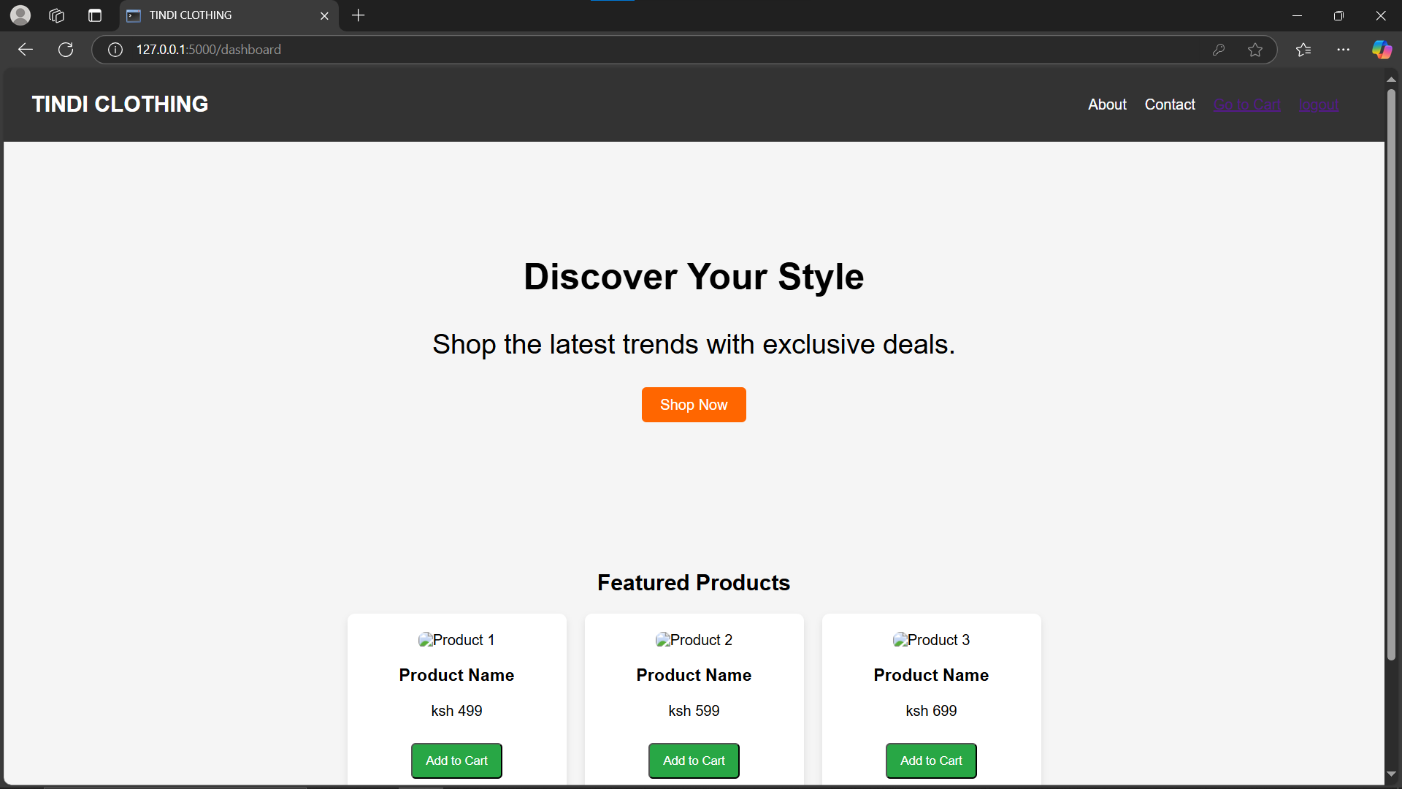
Figure 3: Home page
- This is the dashboard of the system

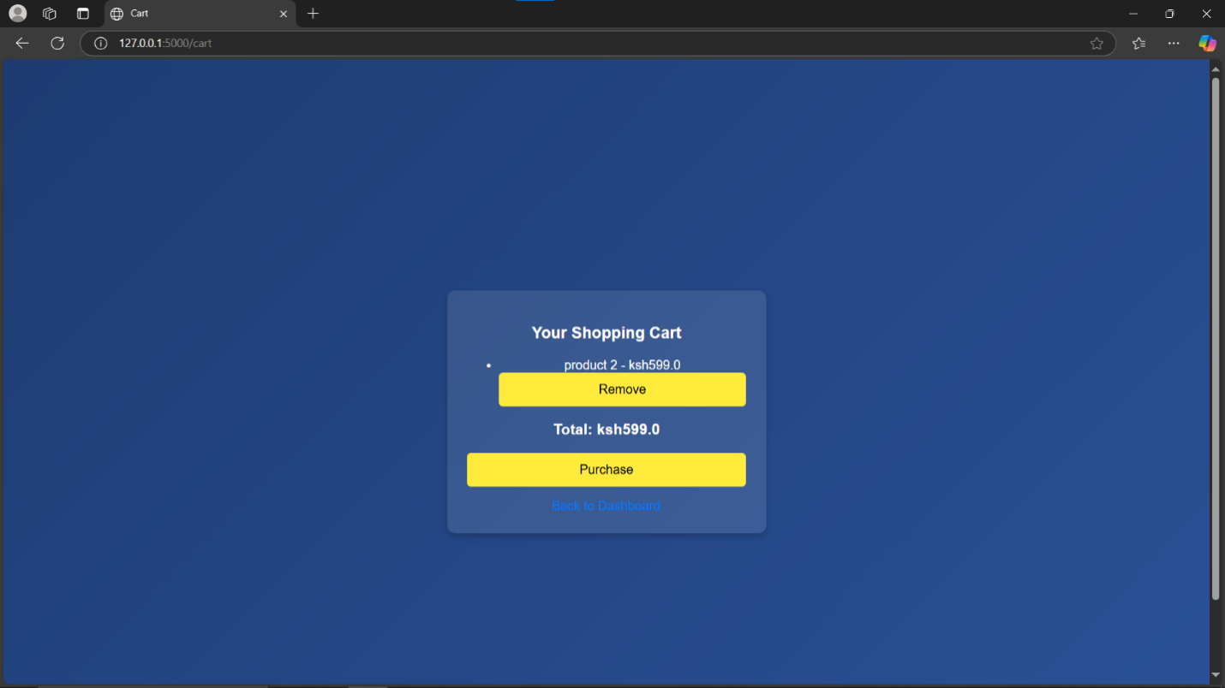
Figure 4: Cart page
- This is the page containing all the items the user selects to buy. They can remove the items selected also.

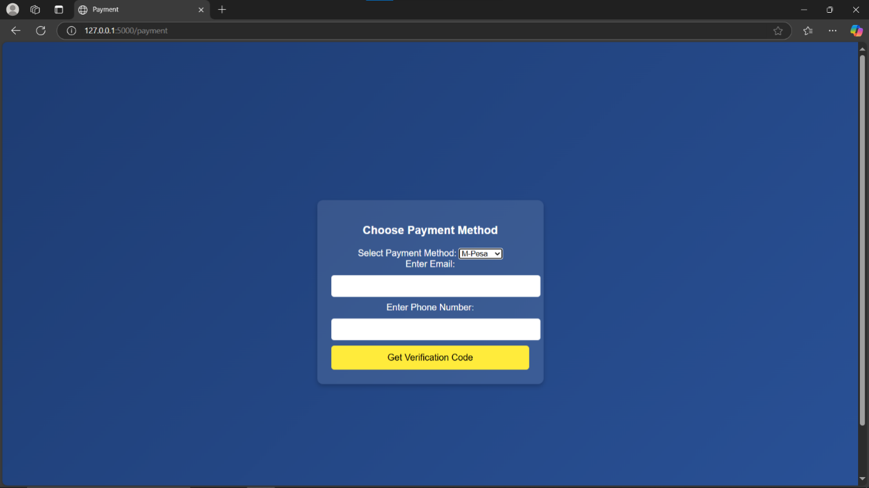
Figure 5: Payment page
- This is where the user enters their email and phone number.

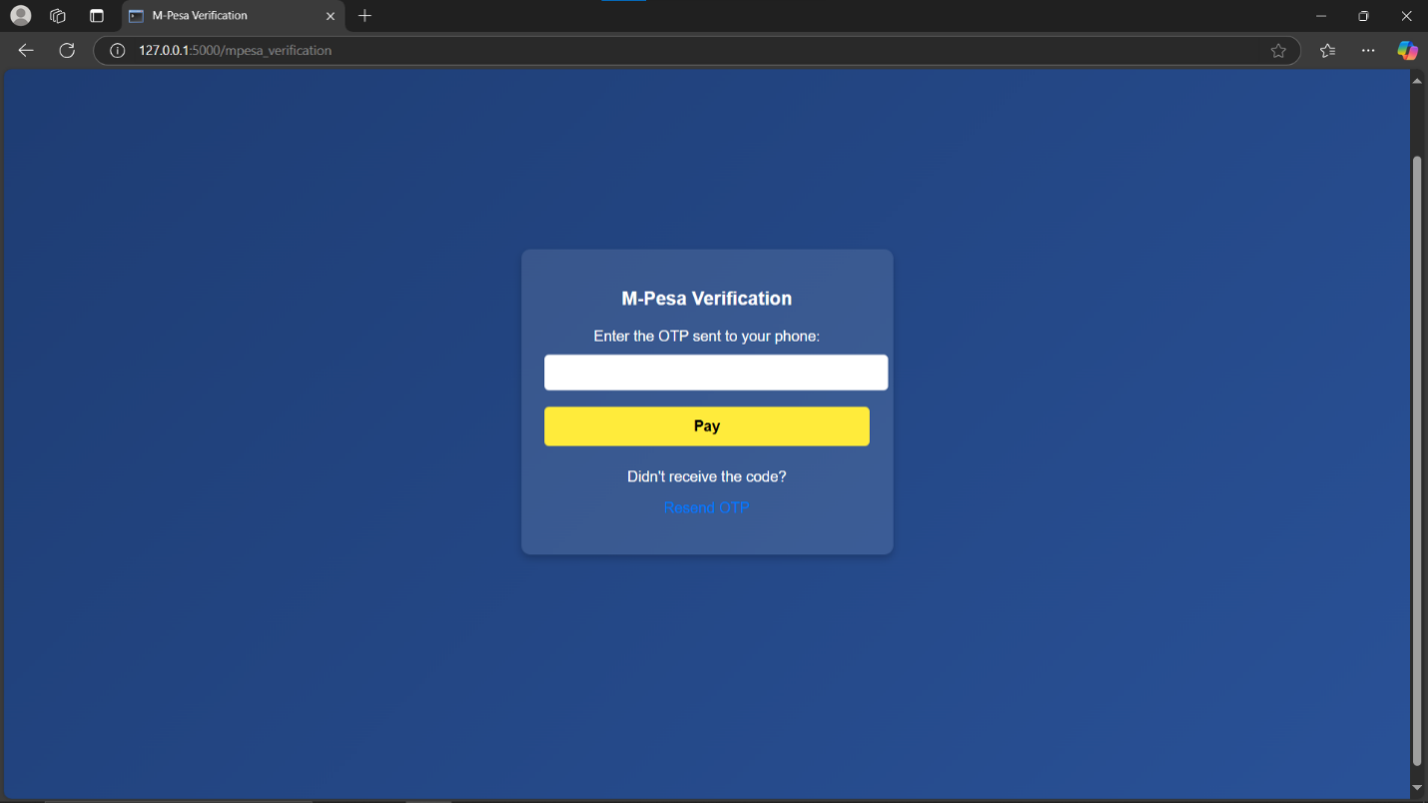
Figure 6: Mpesa Verification page
- This is the page that appears after the user enters their email and phone number and an OTP is sent to the email before processing payment. Here, the user enters the OTP and proceeds to pay. If the user doesn’t receive the OTP, they can request to be resent.
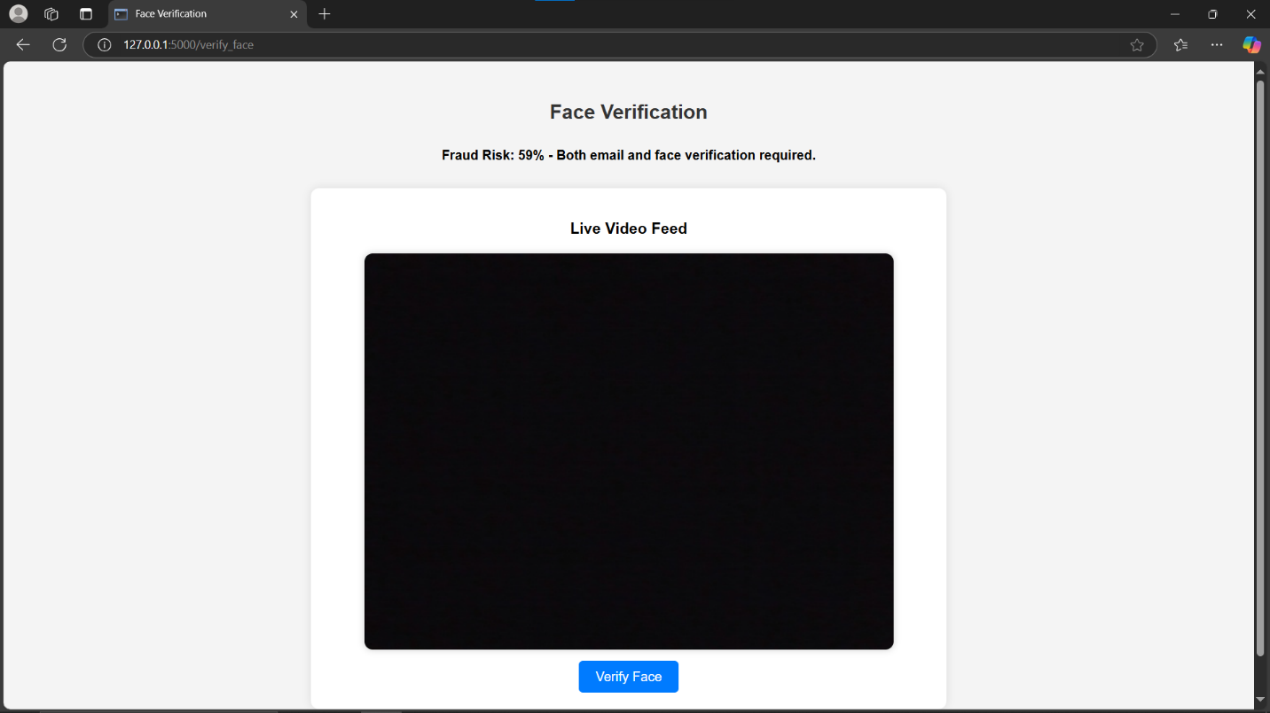
Figure 7: Face Verification Page
- This is where the user is redirected to if the fraud score is above 30%. This verifies the user’s face and compares it with the one registered. The user has a maximum of 3 times to verify face.

Backend Development: Python (Flask)
Flask, a lightweight web framework, was selected for its simplicity and ability to handle API requests efficiently.
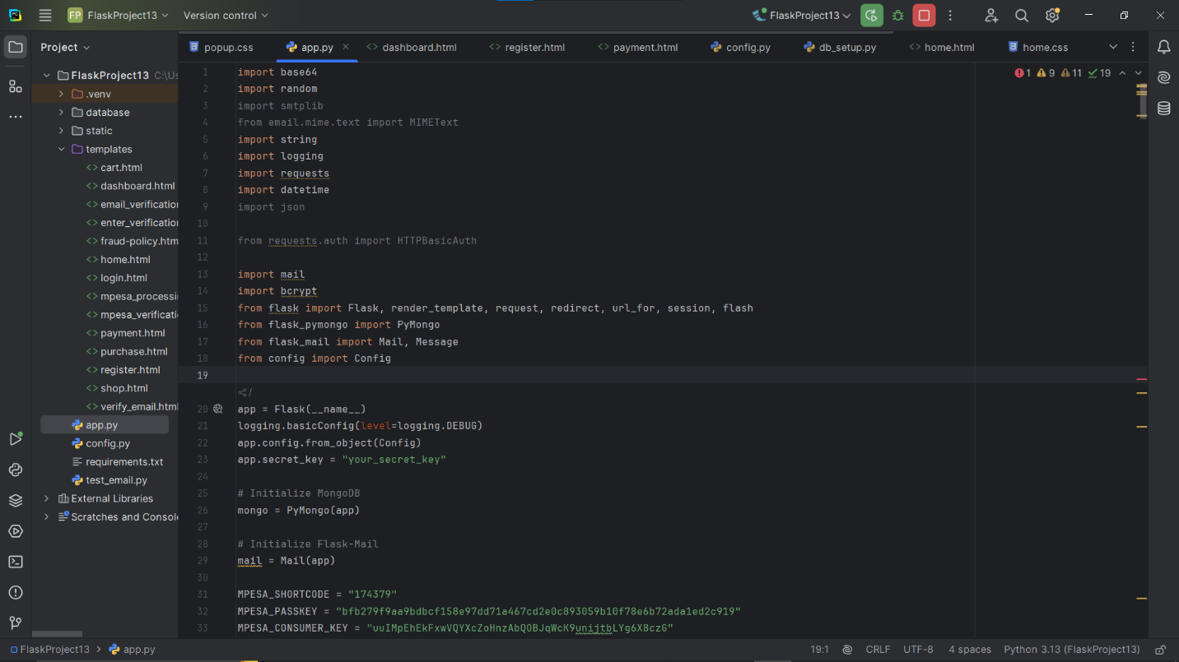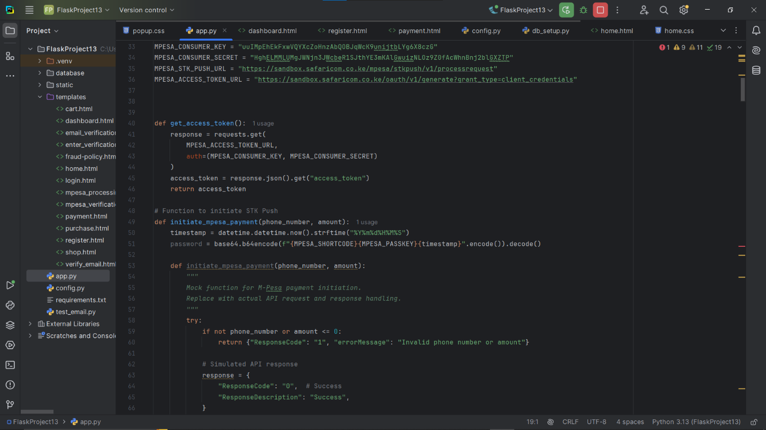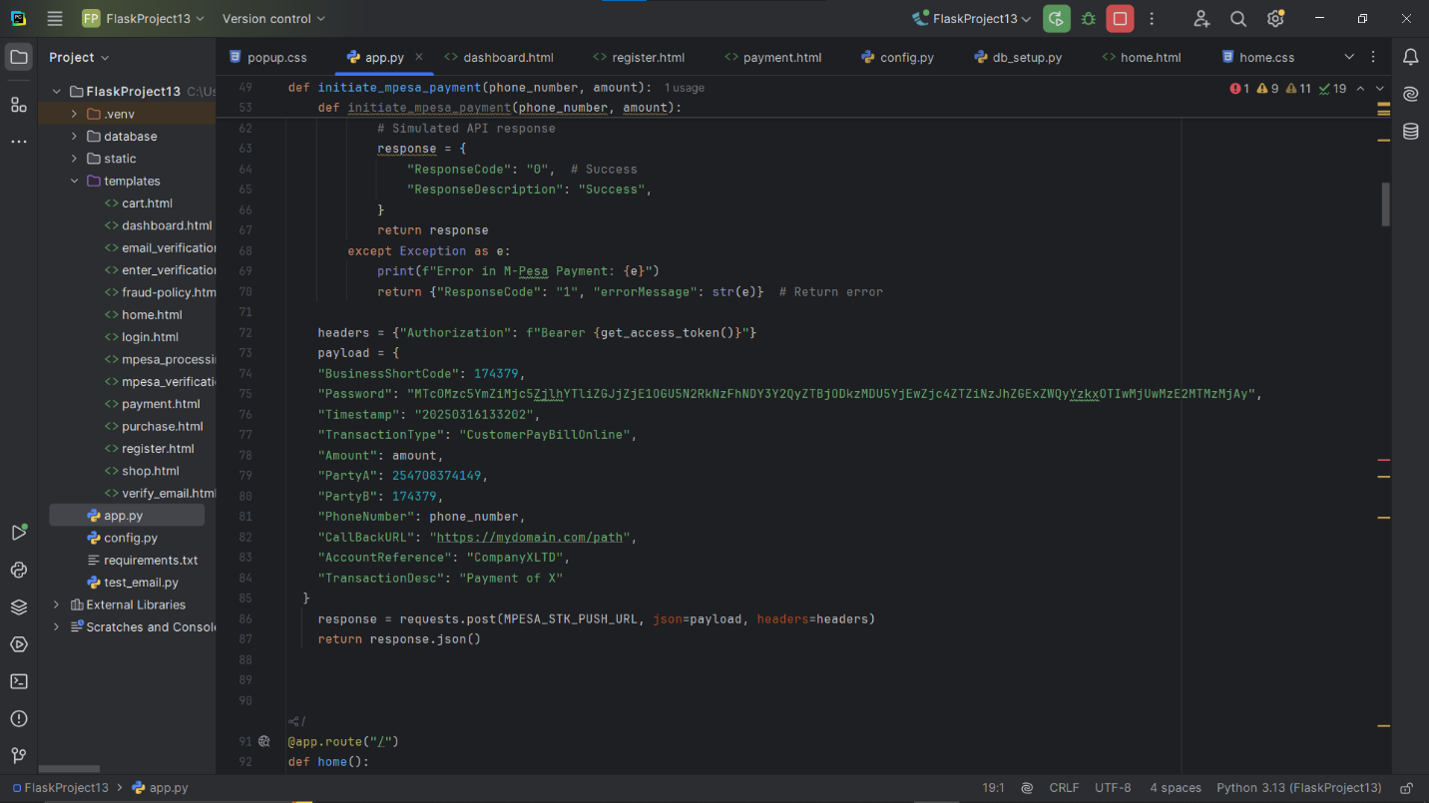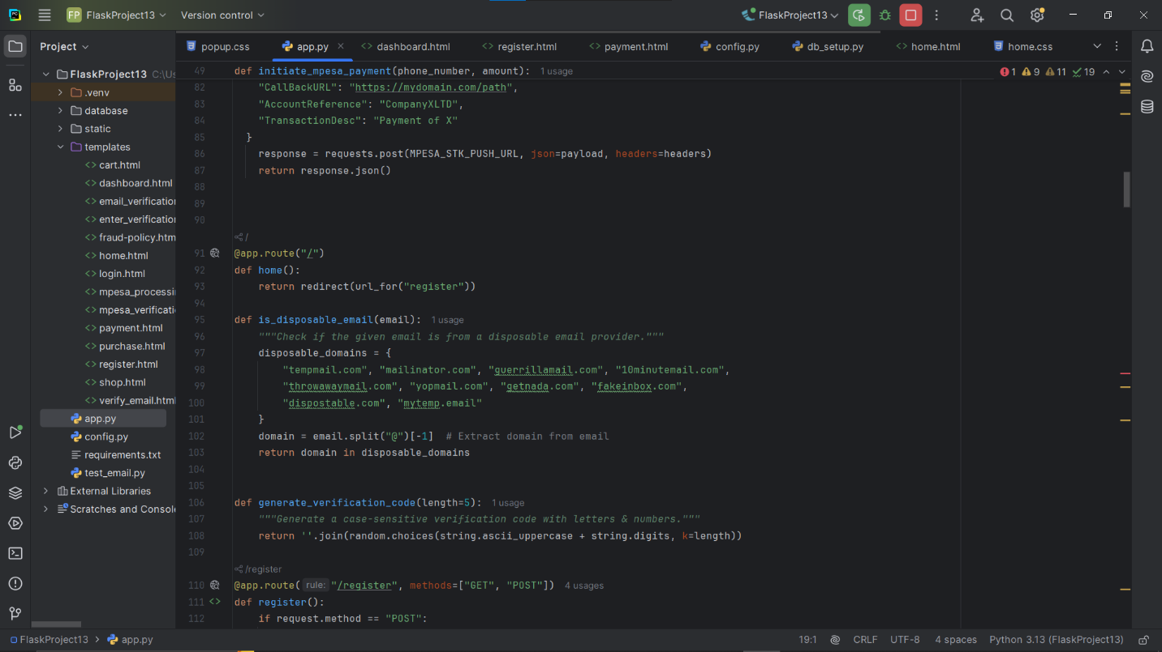
Figure 8: Main
- This is the backend flask app. It contains all the imports, routes for the html pages.
- The main calculates fraud score in percentage based on the following parameters:
- Failed login attempts - 3 failed login attempts is calculated as medium risk while 5 failed login attempts is calculated as high risk.
- Failed transactions - 3 failed transactions are calculated as high risk while 2 failed transactions are calculated as medium risk.
- Previous fraud history – if user has history of fraud and has been blocked before, they are calculated as very high risk
- Drastic IP or Device change – if the first two parts of the IP don’t match, it is calculated as medium risk. A significant IP change might indicated unauthorized access.
Database: MongoDB
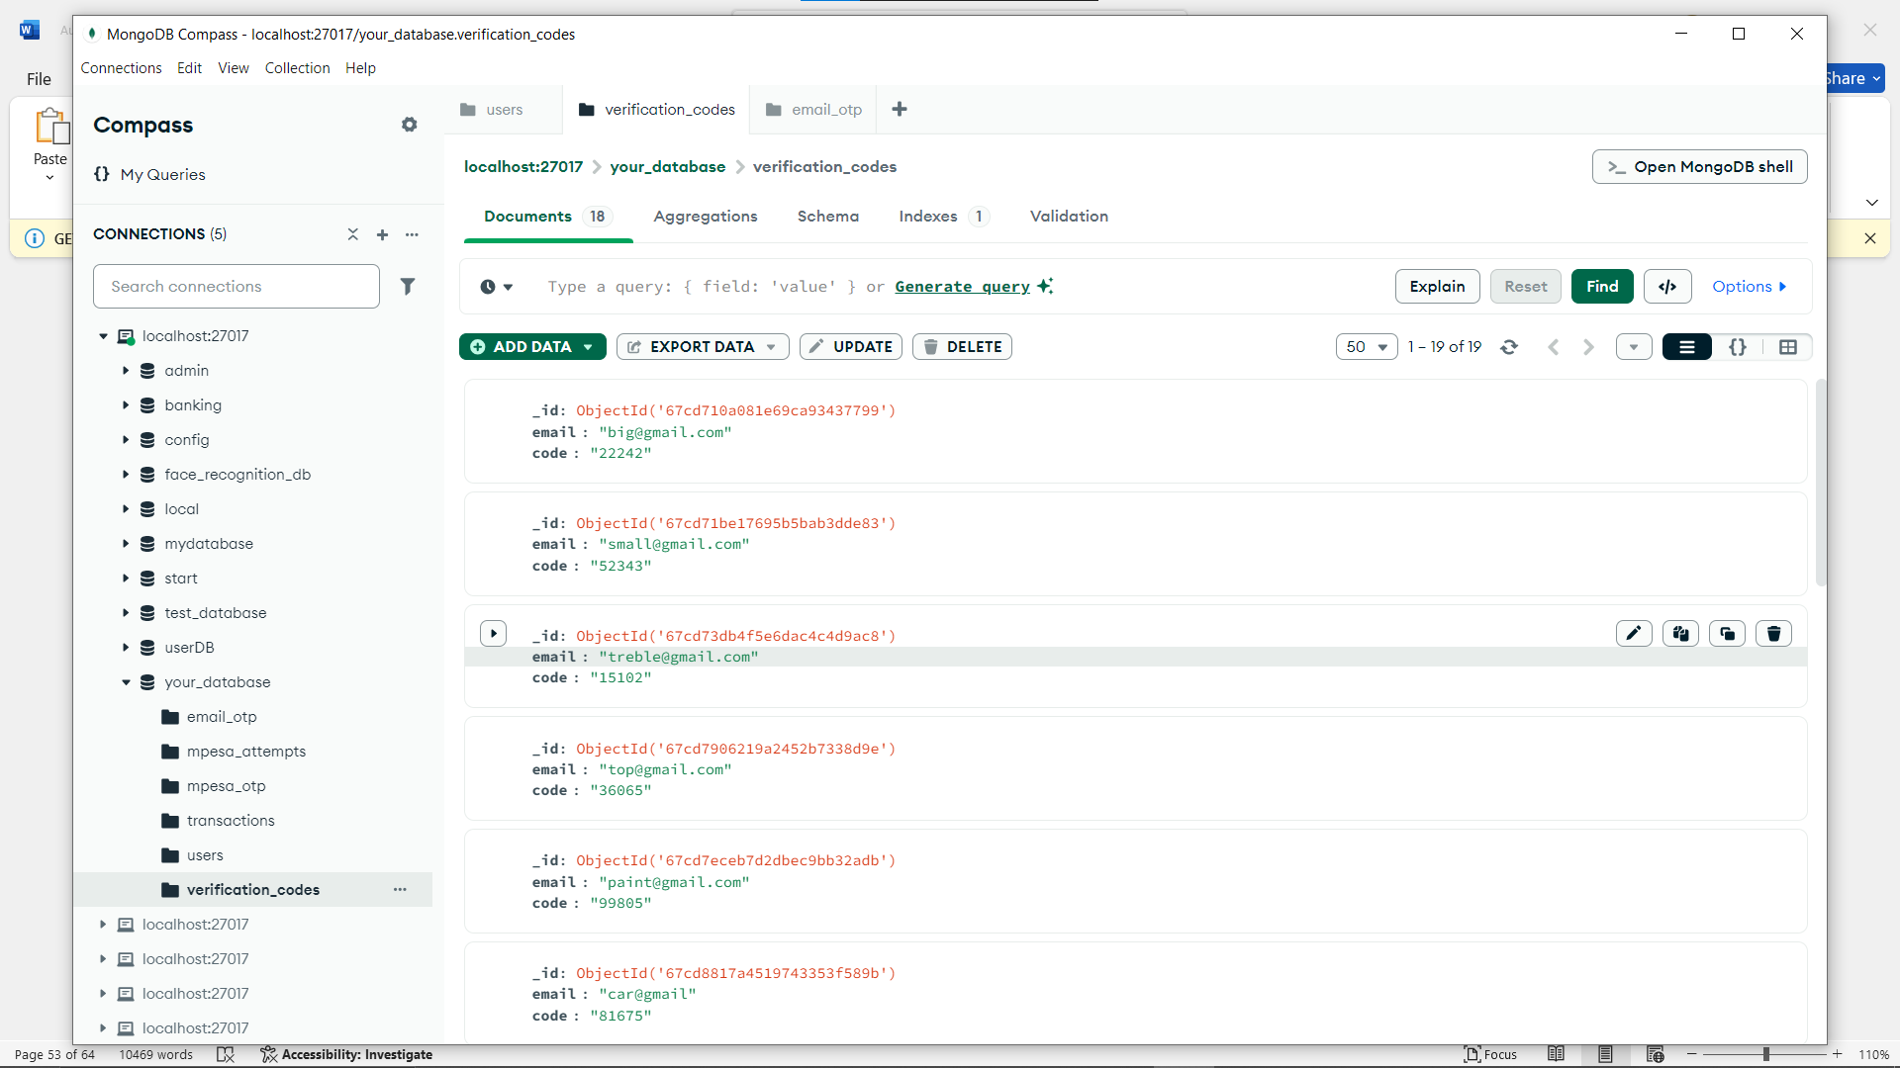
Figure 9: MongoDB
- All the information in the system is stored in the database named “your_database” in various collections.

MongoDB was chosen due to its scalability and ability to store unstructured user authentication and transaction data securely.

Version Control: Git & GitHub
Used for tracking code changes, collaborating and ensuring version management across the development phases.

Development Environment Configuration

Integrated Development Environment (IDE): VS Code was used for both frontend and backend development due to its extensive support for multiple languages and debugging tools.
Git and GitHub: Implemented for version control and collaboration.
Python Virtual Environment: Used to manage dependencies and isolate the Flask application from system-wide packages.
Postman: Utilized for testing API endpoints during backend development.
Security Libraries: Implemented cryptographic functions to enhance MFA security.

4.3 Implementation Steps

Step-by-Step Implementation Plan

Frontend Development
We designed and developed user registration and login interfaces with HTML, CSS, and JavaScript.
We integrated MFA prompts for authentication, including email/SMS verification.
We implemented UI responsiveness to enhance the user experience on multiple devices.

Backend Development
We set up flask to handle authentication and fraud prevention logic.
We developed APIs for user registration, login and MFA verification.
We integrated MongoDB to store user credentials, transaction logs and security logs.

MFA Implementation
We configured MFA options such as OTP via email.
We ensured secure token generation and validation for login authentication.
We implemented fallback authentication methods for enhanced user security.

Testing and Optimization
We conducted unit testing for both frontend and backend components.
We performed penetration testing to evaluate vulnerabilities in authentication.
We optimized system response times and database queries.

Coding Standards and Practices

Clean Code Principles: We applied modular and reusable coding practices to maintain readability and efficiency.
Code Review Process: Peer review and self-auditing to ensure security and performance standards.
Security Best Practices: We used hashing for password storage, secure API endpoints, and proper input validation to prevent vulnerabilities.

4.4 Testing and Quality Assurance

Testing Strategy

Integration Testing: Ensured seamless interaction between frontend and backend, validating authentication flows.
System Testing: Simulated real-world fraud scenarios to verify the robustness of MFA security mechanisms.

Quality Assurance

Functional Testing: Verified that authentication and MFA workflows function correctly.
Non-Functional Testing: Assessed system performance, security and user experience.
Bug Tracking: Used GitHub issues for tracking bugs and resolving system vulnerabilities.
QA Reviews: Conducted peer testing and feedback loops to refine system performance.

4.5 Deployment Plan

Deployment Strategy

Database Hosting: MongoDB Atlas was used to store user authentication data and transaction records securely.
CI/CD Pipeline: GitHub Actions was configured to automate testing and deployment.

Data Migration and Configuration
MongoDB Atlas was configured for secure database storage.
Environment variables were set for API keys, database credentials and authentication settings.
Security headers and CORS policies were configured to prevent unauthorized access.

4.6 Go-Live Plan

Transition to Production

The deployment was planned in phases, starting with a test environment before transitioning to full production.
Implemented automated backups to ensure data recovery in case of failure.
Established a rollback plan in case of critical errors during deployment.

Post-Deployment Strategy

Set up logging and monitoring using Flask logging and MongoDB monitoring tools.
Configured alerts for suspicious login attempts and potential fraud activity.
Collected user feedback to identify areas for improvement and refine the authentication process.

4.7 Maintenance and Support

Maintenance Support

Scheduled weekly security patches.
Regularly updated dependencies to prevent vulnerabilities.
Monitored user activity for fraud attempts.

User Support

Created a FAQ and troubleshooting guide.
Set up a support ticketing system (via GitHub Issues).
Provided email-based support.

4.8 Conclusion and Future Work

This project successfully implemented an e-commerce platform with robust MFA security measures, ensuring secure transactions and fraud prevention. The integration of Flask and MongoDB provided a scalable and efficient system.
Future work includes:
- Implementing biometric authentication (Face ID, Fingerprint)
- Enhancing fraud detection with AI-driven anomaly detection
- Expanding multi-currency support for global transactions
This project highlights the significance of multi-factor authentication in securing e-commerce platforms, paving the way for further research and innovation in cybersecurity.

CHAPTER 5

CONCLUSION AND RECOMMENDATIONS

5.1 CONCLUSION

The development of an e-commerce fraud prevention system using Multi-Factor Authentication (MFA) has been an essential step in enhancing online transaction security. The project successfully implemented a robust authentication mechanism that strengthens user verification processes, reducing the risk of fraudulent activities such as unauthorized access, identity theft, and payment fraud. By integrating Flask and Python for backend operations, MongoDB for secure data storage, and a frontend developed with HTML, CSS, and JavaScript, the system ensures a seamless and user-friendly experience while maintaining high-security standards.
This project highlights the significance of MFA in e-commerce security. Unlike traditional single-factor authentication, the implemented system requires multiple verification steps, making it more challenging for malicious actors to gain unauthorized access. The solution effectively balances security and usability, ensuring that legitimate users can easily authenticate while deterring fraudulent activities. Additionally, the system aligns with best security practices by leveraging encryption and secure database management.
While the system provides significant improvements in fraud prevention, it is not without limitations. The reliance on user compliance with authentication measures, potential usability concerns with MFA, and the need for continuous monitoring of emerging fraud techniques highlight areas for future improvement. Nonetheless, this project serves as a foundation for further enhancements and implementation in real-world e-commerce platforms.

5.2 RECOMMENDATIONS

To enhance the effectiveness and sustainability of the fraud prevention system, the following recommendations are suggested:

5.2.1 Implementation of Adaptive Authentication
Future improvements should consider implementing adaptive authentication, which dynamically adjusts security requirements based on user behavior and risk assessment. This approach can improve the balance between security and user experience by requiring additional authentication factors only when a transaction is deemed high-risk.

5.2.2 Integration with Biometric Authentication
To further enhance security, integrating biometric authentication methods such as fingerprint or facial recognition could provide an additional layer of protection. This would reduce dependency on passwords and OTPs, which are susceptible to phishing and interception.

5.2.3 Regular Security Audits and Updates
Since cyber threats are constantly evolving, it is essential to conduct regular security audits and updates to identify vulnerabilities and strengthen system defenses. Ensuring that the system complies with the latest security standards will help maintain its effectiveness against new fraud tactics.

5.2.4 User Education and Awareness
Users play a critical role in maintaining security. Providing educational resources and awareness programs about phishing attacks, password security, and the importance of MFA can help prevent social engineering attacks and increase overall system security.

5.2.5 Scalability and Performance Optimization
As the system expands, it should be optimized for scalability to accommodate a growing number of users and transactions. Implementing load balancing, database optimization, and efficient API calls will ensure that the system remains responsive and reliable under high traffic.

APPENDICES

Appendix A: System Architecture & Design

- System Architecture Diagram - A high-level overview of system components and how they interact (Flask backend, MongoDB, front-end, fraud detection engine, payment gateways).
- Entity-Relationship Diagram (ERD) - Shows database structure, including collections for users, transactions, fraud attempts, and risk scoring.
- Data Flow Diagram (DFD) - Illustrates data movement in key processes like user authentication, payment verification, and fraud scoring.

Appendix B: Technical Documentation

System Requirements

- Hardware: Minimum server specs (CPU, RAM, Storage).
- Software: Flask, Python, MongoDB, OpenCV (for face recognition), and Stripe/M-Pesa APIs.

API Documentation

User Authentication API
Endpoint | Method | Description
/register | POST | Registers a new user
/login | POST | Authenticates users
/verify_face | POST | Compares live face encoding with stored encoding
/fraud_score | GET | Returns fraud risk score for a user

Payment Processing API

Endpoint | Method | Description
/mpesa_verification | POST | Starts M-Pesa transaction

Appendix C: Security & Fraud Prevention Measures

Fraud Risk Scoring Algorithm
Risk factors considered:
  - Failed login attempts
  - Previous fraudulent history
  - Mismatched IP or device
  - Randomized risk factor for unpredictability

Multi-Factor Authentication (MFA) Implementation
Steps:
- User logs in with email & password
- System checks fraud score
- If risk is high, additional verification is required (Face Recognition or OTP)

Appendix D: Test Cases & Results

Authentication Test Cases
Test Case | Expected Output | Actual Output | Status
Login with correct credentials | Redirect to dashboard | Passed | Working
Login with incorrect password | Show error message | Passed | Working
Face recognition with mismatched face | Deny access | Passed | Working
Table 3: Authentication Test Cases

Fraud Detection Test Cases
Test Case | Expected Fraud Score | Actual Score | Status
User with 5 failed logins | High Risk (Above 90%) | Passed | Working
User with new device login | Moderate Risk (50-70%) | Passed | Working
Table 4: Fraud Detection Test Cases

REFERENCES
Abu Bakar, K. A., & Haron, G. R. (2014). Adaptive authentication based on analysis of user behavior. 2014 Science and Information Conference, 601–606. https://doi.org/10.1109/SAI.2014.6918248
Albshaier, L., Almarri, S., & Hafizur Rahman, M. M. (2024). A Review of Blockchain’s Role in E-Commerce Transactions: Open Challenges, and Future Research Directions. In Computers (Vol. 13, Issue 1). Multidisciplinary Digital Publishing Institute (MDPI). https://doi.org/10.3390/computers13010027
Alhakami, H., & Alhrbi, S. (2020). Knowledge based Authentication Techniques and Challenges. In IJACSA) International Journal of Advanced Computer Science and Applications (Vol. 11, Issue 2). www.ijacsa.thesai.org
Amft, S., Höltervennhoff, S., Huaman, N., Krause, A., Simko, L., Acar, Y., & Fahl, S. (2023). “We’ve Disabled MFA for You”: An Evaluation of the Security and Usability of Multi-Factor Authentication Recovery Deployments. CCS 2023 - Proceedings of the 2023 ACM SIGSAC Conference on Computer and Communications Security, 3138–3152. https://doi.org/10.1145/3576915.3623180
Badi, S., Hassan, F., & Mirza, D. (2021). Boosting Ecommerce Security: Implementing Multi-Factor Authentication (MFA) and Advanced Cyber Forensics. https://doi.org/10.13140/RG.2.2.30388.87685
Brineth Balisong, S., Keziah, B., Fernandez, N., & Logronio, N. A. (2021). E-COMMERCE FRAUD: EFFECTS OF ONLINE SELLING EXPERIENCES TO. https://ssrn.com/abstract=3835781
Byrapu Reddy, S. R., Kanagala, P., Ravichandran, P., Pulimamidi, D. R., Sivarambabu, P. V., & Polireddi, N. S. A. (2024). Effective Fraud Prevention in e-commerce: Leveraging machine learning and big data analytics. Measurement: Sensors, 33, 101138. https://doi.org/10.1016/j.measen.2024.101138
Chawla, N., & Kumar, B. (2022). E-Commerce and Consumer Protection in India: The Emerging Trend. Journal of Business Ethics, 180(2), 581–604. https://doi.org/10.1007/s10551-021-04884-3
Cheney, J. S. (2005). Identity Theft: Do Definitions Still Matter? www.ftc.gov/os/statutes/itada/itadact.htm.
Courage Idemudia, Edith Ebele Agu, & Shadrack Obeng. (2024). Analysis of machine learning techniques in detecting and preventing e-commerce fraud effectively. International Journal of Frontiers in Science and Technology Research, 7(1), 025–034. https://doi.org/10.53294/ijfstr.2024.7.1.0046
Donald, E. C., Bumpus, M. A., & Zhang, X. (2021). A case study in selection and deployment of a multi-factor authentication solution. Issues in Information Systems, 22(3), 62–72. https://doi.org/10.48009/3_iis_2021_69-80
Godawale, S., & Deshmukh, P. (2024). IMPACT OF BLOCKCHAIN TECHNOLOGY IN THE E-COMMERCE SECTOR. Journal of Trends and Challenges in Artificial Intelligence, 1(4), 127–132. https://doi.org/10.61552/JAI.2024.04.002
Haller, N. (1996). Network Working Group.
Hameed, A., Mohammed, Y., Dziyauddin, R. A., & Latiff, L. A. (n.d.). Current Multi-factor of Authentication: Approaches, Requirements, Attacks and Challenges. In IJACSA) International Journal of Advanced Computer Science and Applications (Vol. 14, Issue 1). www.ijacsa.thesai.org
Jain, A. K. ., Bolle, Ruud., & Pankanti, Sharath. (20061996). Biometrics : personal identification in networked society. Springer.
Jeng, A. B., Tseng, C.-C., Tseng, D.-F., & Wang, J.-C. (2010). A Study of CAPTCHA and Its Application to User Authentication. In LNAI (Vol. 6422).

Johnson, S. C., & Schmidt, W. (n.d.). Operational Disruption Exposure and Part Inventory Replenishment Xiaobo Ding. https://ssrn.com/abstract=3715203
Lian, J. W., & Lin, T. M. (2008). Effects of consumer characteristics on their acceptance of online shopping: Comparisons among different product types. Computers in Human Behavior, 24(1), 48–65. https://doi.org/10.1016/J.CHB.2007.01.002
Manjulatha*, B., & Pabboju, Dr. S. (2019). Big Data Analytics and Its Applications. International Journal of Recent Technology and Engineering (IJRTE), 8(4), 10928–10931. https://doi.org/10.35940/ijrte.D4456.118419
Mavroeidis, V., Vishi, K., Zych, M. D., & Jøsang, A. (2018). The Impact of Quantum Computing on Present Cryptography. In IJACSA) International Journal of Advanced Computer Science and Applications (Vol. 9, Issue 3). www.ijacsa.thesai.org
Meyer, L. A., Romero, S., Bertoli, G., Burt, T., Weinert, A., & Ferres, J. L. (2023). How effective is multifactor authentication at deterring cyberattacks? http://arxiv.org/abs/2305.00945
Nanduri, V. S. (2024). Strengthening Security: Implementation of Multi-Factor Authentication (MFA) in Data Center Environment. International Journal of Scientific Research in Engineering and Management. https://doi.org/10.55041/IJSREM37063

Nwokedi, U. O., Onyimbo, B. A., & Rad, B. B. (2016). Usability and Security in User Interface Design: A Systematic Literature Review. International Journal of Information Technology and Computer Science, 8(5), 72–80. https://doi.org/10.5815/ijitcs.2016.05.08
Ometov, A., Bezzateev, S., Mäkitalo, N., Andreev, S., Mikkonen, T., & Koucheryavy, Y. (2018). Multi-factor authentication: A survey. Cryptography, 2(1), 1–31. https://doi.org/10.3390/cryptography2010001
Premsai, R. (2024). EVALUATING THE IMPACT OF MULTI FACTOR AUTHENTICATION ON CYBERSECURITY EFFECTIVENESS. International Scientific Journal of Engineering and Management, 03(12), 1–6. https://doi.org/10.55041/ISJEM02098
Sarpong Adu-Manu, K., Kwasi Ahiable, R., Kwame Appati, J., & Essel Mensah, E. (2022). Phishing Attacks in Social Engineering: A Review. Journal of Cyber Security, 4(4), 239–267. https://doi.org/10.32604/jcs.2023.041095
Saxena, G. (2015). “Legal And Taxation Issues Concerning E-Commerce.” Indian Journal of Law and Technology, 11(1). https://doi.org/10.55496/jeoj3922
Taneski, V., Heričko, M., & Brumen, B. (n.d.). Systematic Overview of Password Security Problems. In Acta Polytechnica Hungarica (Vol. 16, Issue 3).

Vanini, P., Rossi, S., Zvizdic, E., & Domenig, T. (2023). Online payment fraud: from anomaly detection to risk management. Financial Innovation, 9(1). https://doi.org/10.1186/s40854-023-00470-w
Wee, A. K., Chekole, E. G., & Zhou, J. (2024). Excavating Vulnerabilities Lurking in Multi-Factor Authentication Protocols: A Systematic Security Analysis. http://arxiv.org/abs/2407.20459
Zhang, D., Frei, R., Senyo, P. K., Bayer, S., Gerding, E., Wills, G., & Beck, A. (2023). Understanding fraudulent returns and mitigation strategies in multichannel retailing. Journal of Retailing and Consumer Services, 70. https://doi.org/10.1016/j.jretconser.2022.103145

